Tanmay Fadnavis

SUID: 971141760

INTERNET Security

Lab - 1

# TASK 1: PACKET SNIFFING PROGRAM

**Task 1 a : Understanding sniffex.**

Below are the screen shots and the explanation for the same.

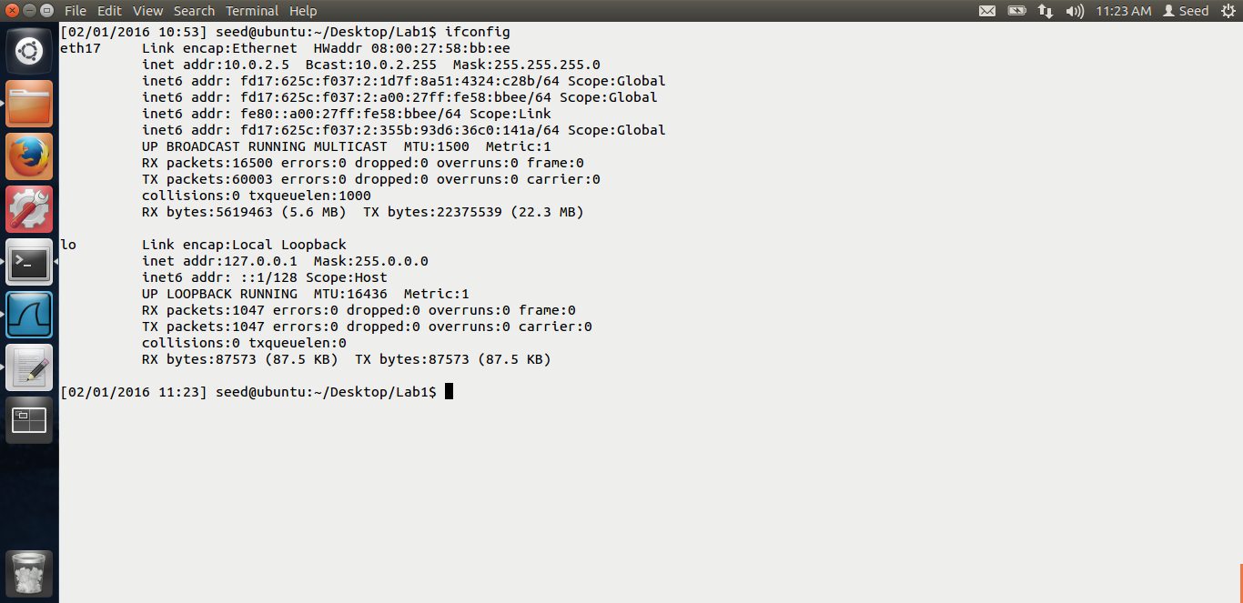

In the above screen shot, we can see the ip of the virtual box, 10.0.2.5

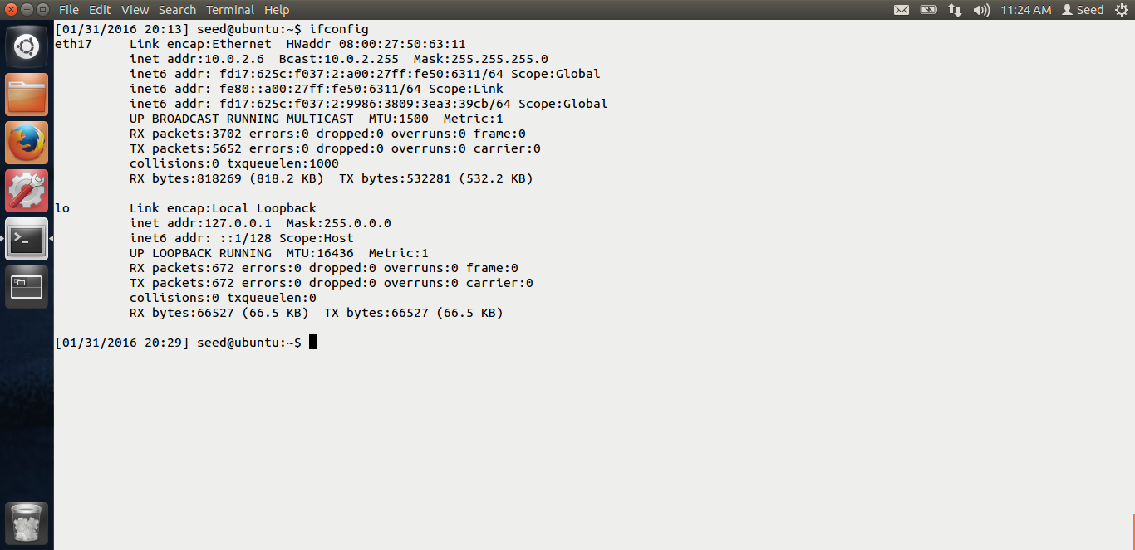

This is the screen shot of the clone machine. The ip is 10.0.2.6 Now, I will run the sniffex program and do a ping from clone to the original VM.

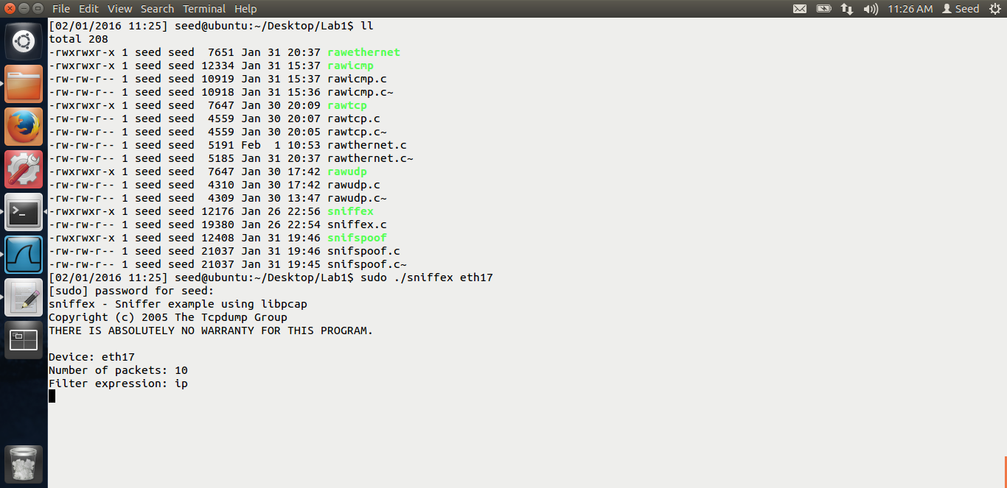

In the above screen shot, we can see that I am running the sniffex program. Now I will start the ping.

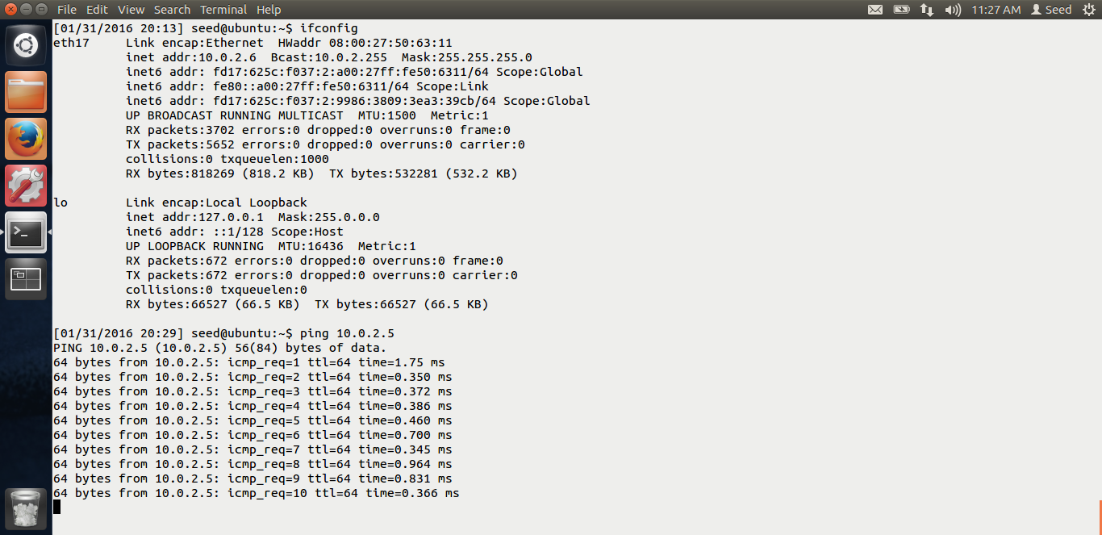

In the above screen shot, we can see that, I am pinging the original vm from the clone. Our sniffex program will capture these packets.

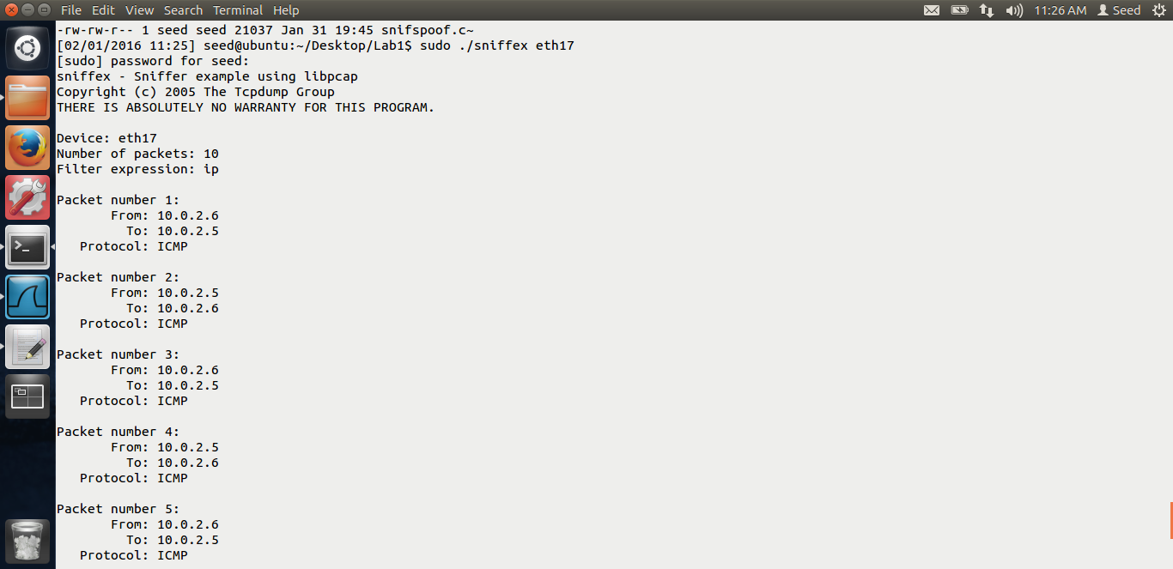

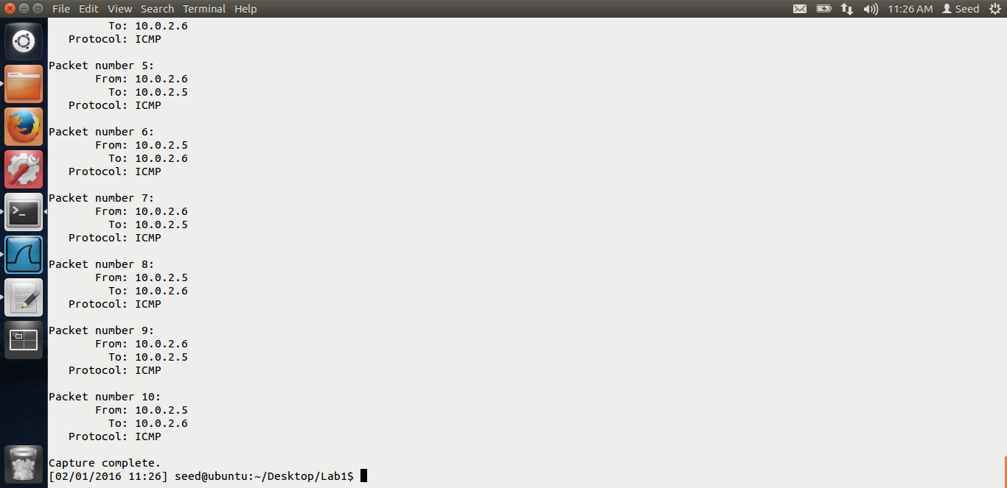

In the above screen shots, we can see that the sniffex program has captured i.e. sniffed these traffic.

**Problem 1**: The library calls are as follows.

First, we will find the capture device, i.e the NIC card on which to sniff.

pcap_lookupdev() Does this for us.

Then, we will initialize the sniffing session with the help of this function.

pcap_open_live(dev, SNAP_LEN, 1, 1000, errbuf); This will open the session for us.

If we want to sniff some particular traffic, we can then compile and set the filters. This is an optional step. pcap_compile() and pcap_setfilter() These functions are used to do the same.

Now, we will start the sniffing session using the function, pcap_loop(handle, num_packets, got_packet, NULL); This pcap_loop function will start sniffing the traffic, and once it captures the traffic, got_packet, this callback function is being called.

Once we are done with the sniffing, we close the session using the function, pcap_close().

These are the above library calls essential for sniffer program.

**Problem 2:** Why do we need root priviledge.?

As socket can only be used by root, we need a root priviledge to run the sniifex program.

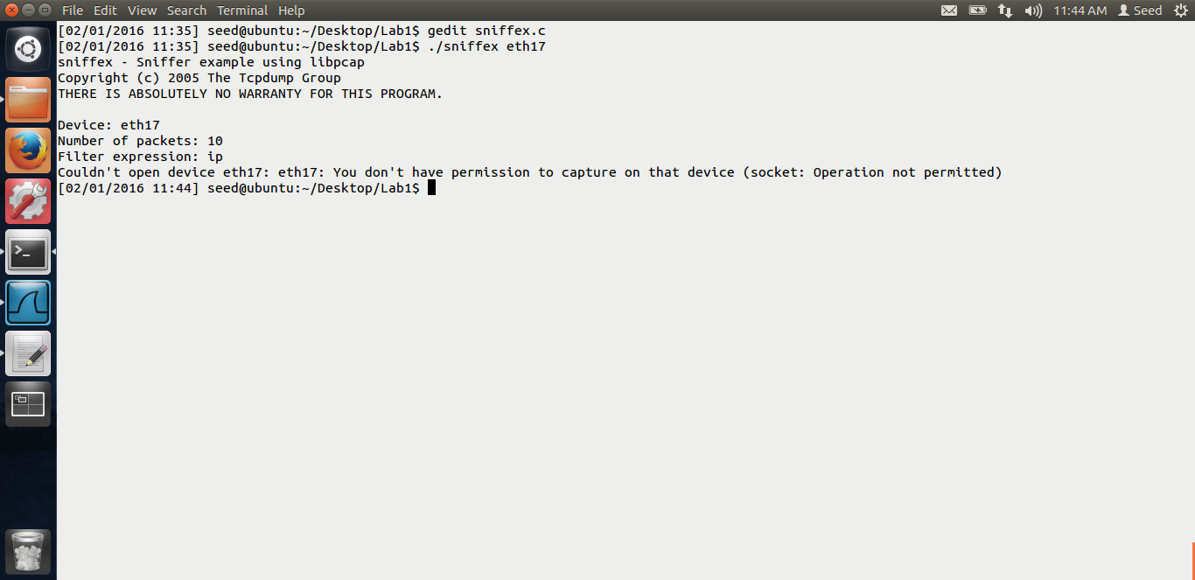

As you can see from the above screen shot, if we run the sniffex as normal user, we cannot access the device, eth17 in my case and the program fails.

**Problem 3:** Turn on and off the promiscuous mode and see the difference.

First, let me keep the promiscuous mode on. Now, I will ping google.com from the clone VM, and let us see if the packets are being captured. The promiscuous mode I have turned on in the original VM.

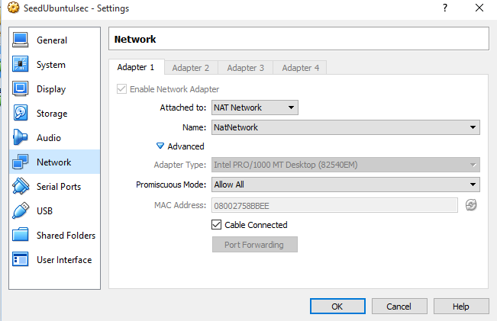

Above is the screen shot.

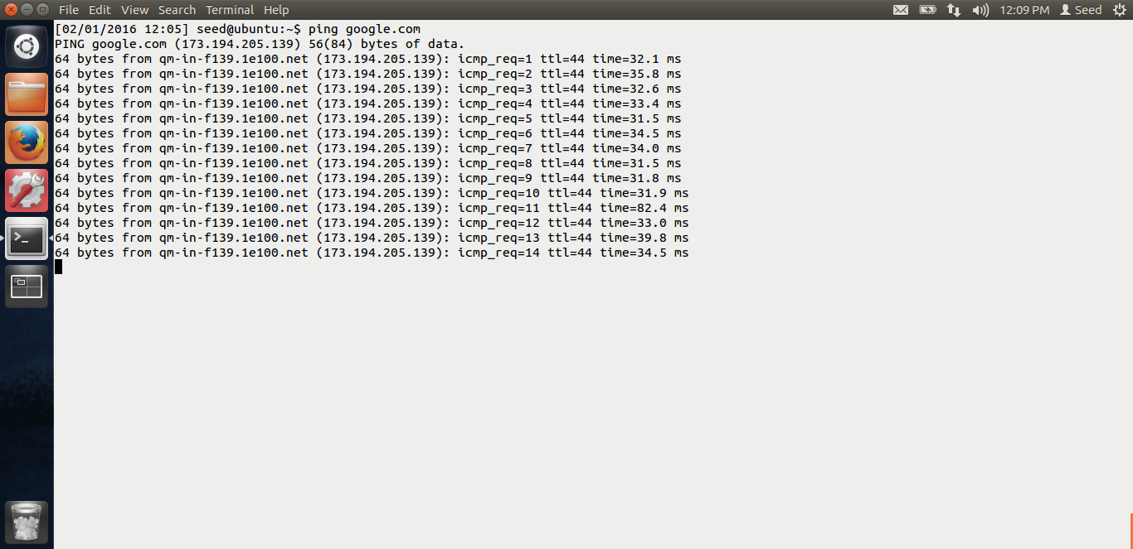

In the screen shot, we can see that I am pinging google.com from other vm i.e. the cloned vm.

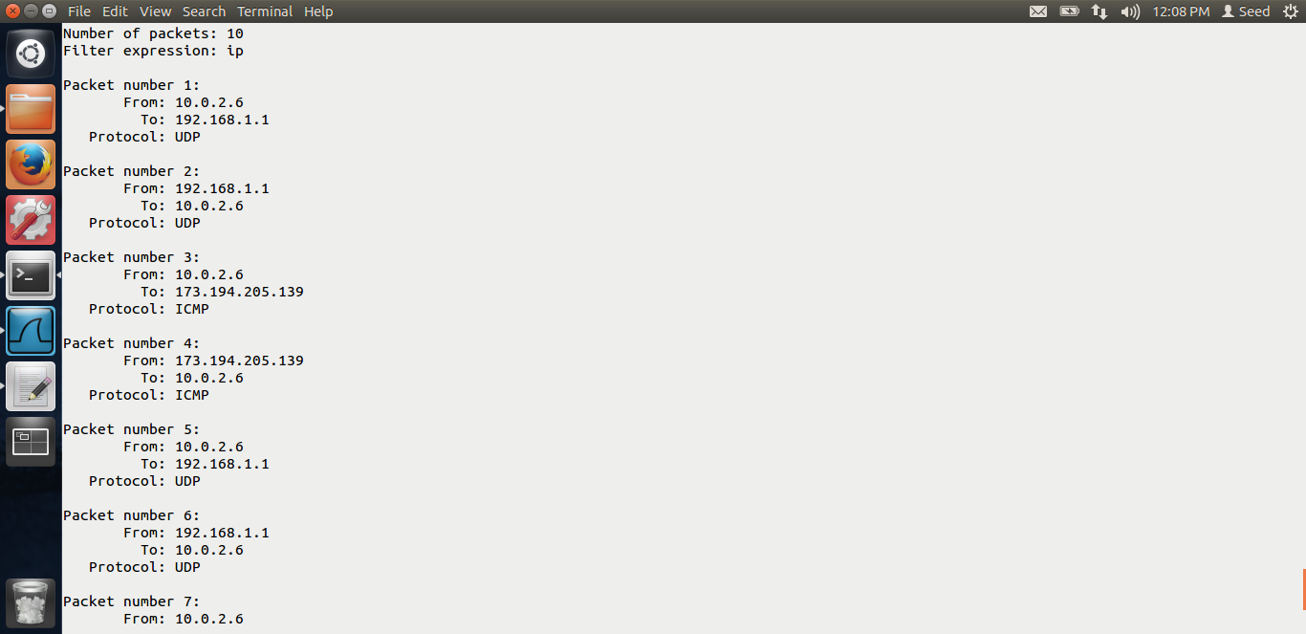

My sniifex program is running in the original vm. We can see from the above screen shot, that the packets are being captured, packets between the clone vm and google.com

Now let us turn off the promiscuous mode. And try the same.

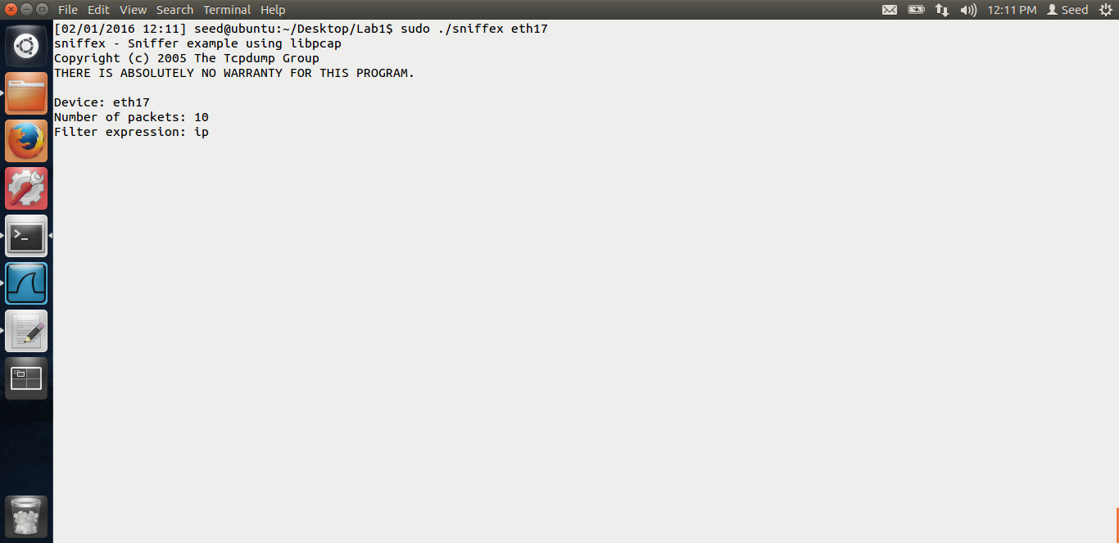

I am running the sniffex on my original vm.

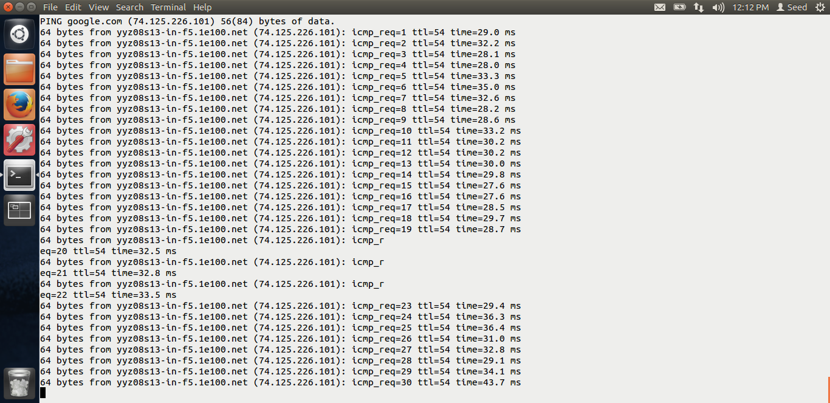

I am pinging google.com from the cloned vm.

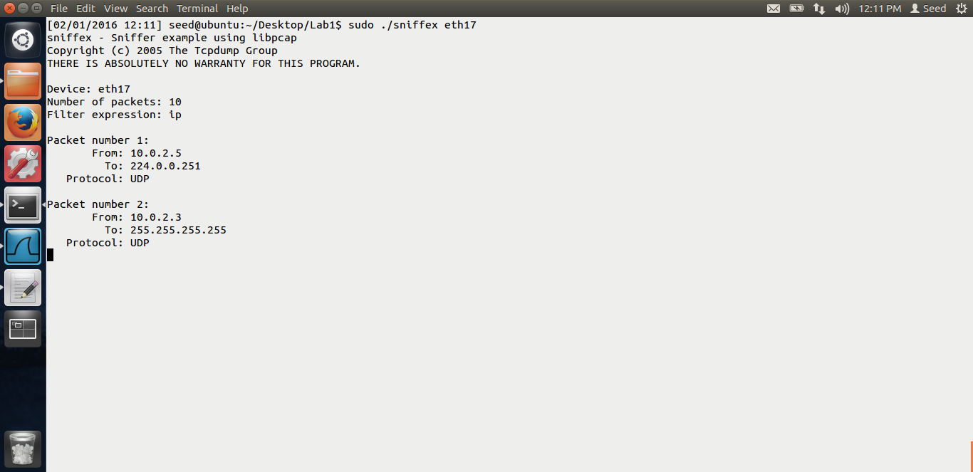

Even though I am pinging google.com, we cannot see those packets being captured in our sniffex program, no source as 10.0.2.6 Thus, this is the difference, if the promiscuous mode is off, we cannot sniff packets from different computer even in the same network.

**Task 1.b: Writing filters.**

The screen shots for writing filters and explanation is below.

ICMP packet between 2 specific hosts.

I just changed the filter expression in the sniffex program. The screen shot is below.

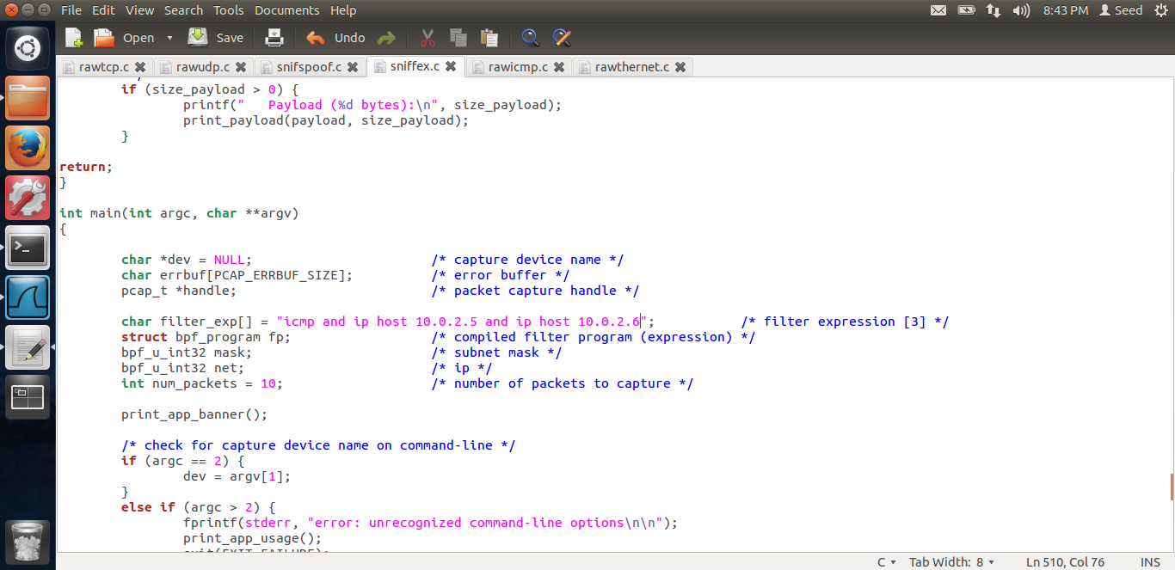

In the above screen shot, we can see that, the filter I have added is icmp and ip host my original vm ip and ip host my clone vm ip. Thus, the sniffex will only capture ICMP packets between these 2 hosts. Below is the output.

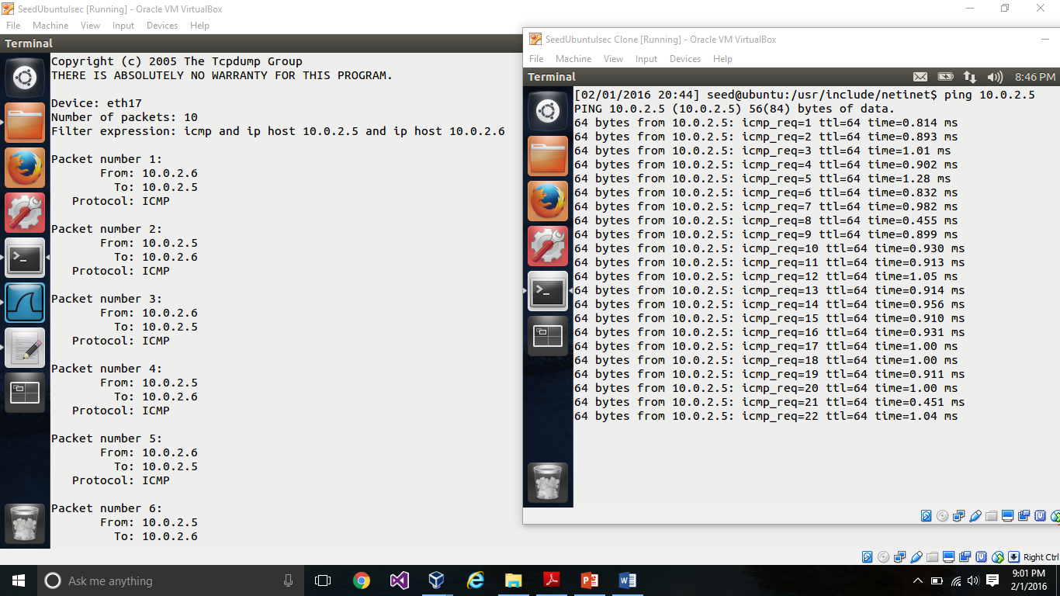

When I ping from my clone vm to my original vm, The packets are being captured. On the left hand side, we can see that, the sniffex program captures the ICMP packets, src 10.0.2.6 and dst 10.0..5 and vice versa.

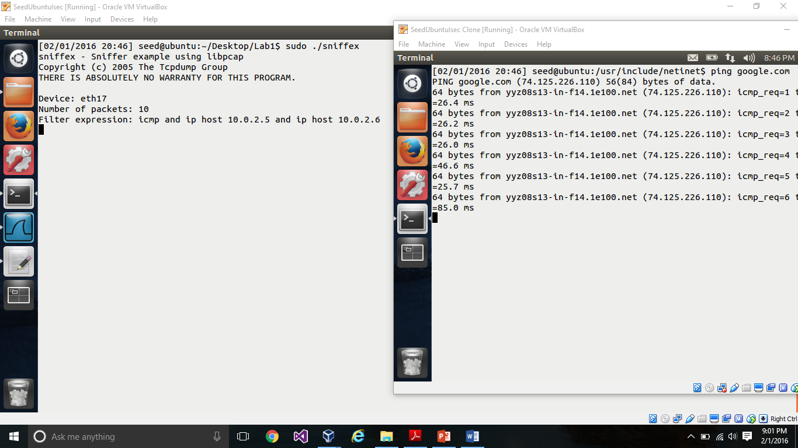

But when I ping google.com from my clone vm, the packets are not being captures even though the clone vm is getting the reply. Thus, my filter expression works.

2. TCP packets which have a destination port range 10 – 100.

The filter expression for the above is,

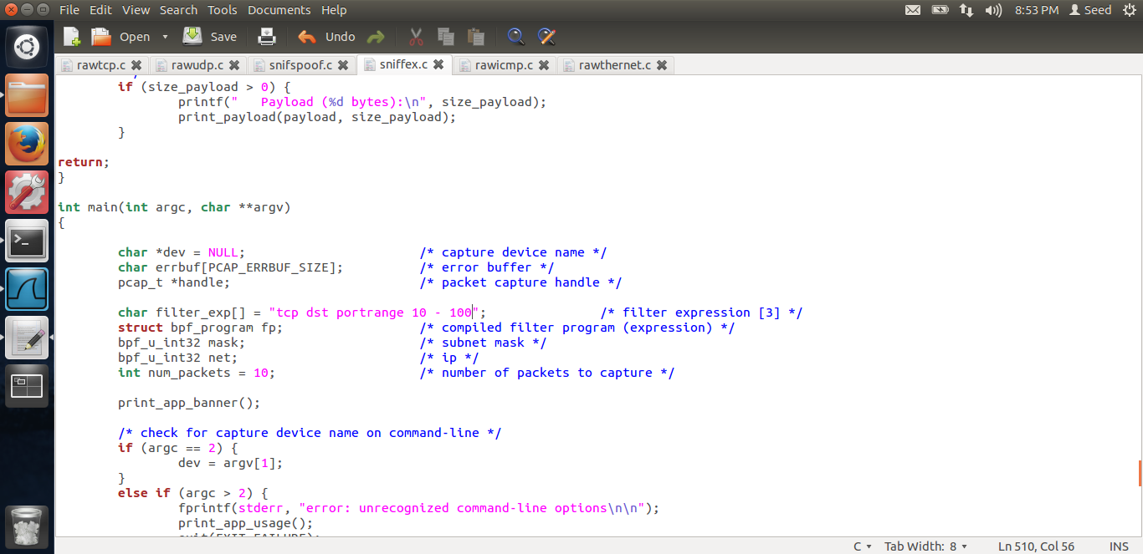

From the screen shot, we can see that the filter expression is “tcp dst portrange 10-100”

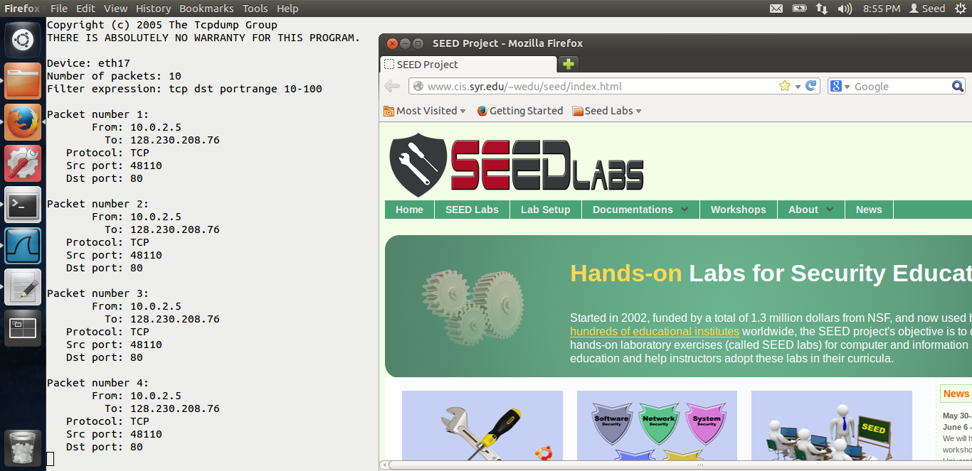

From the above screen shot, we can see that, when I open Mozilla, tcp requests are generated and caught by our program, as the destination port is 80.

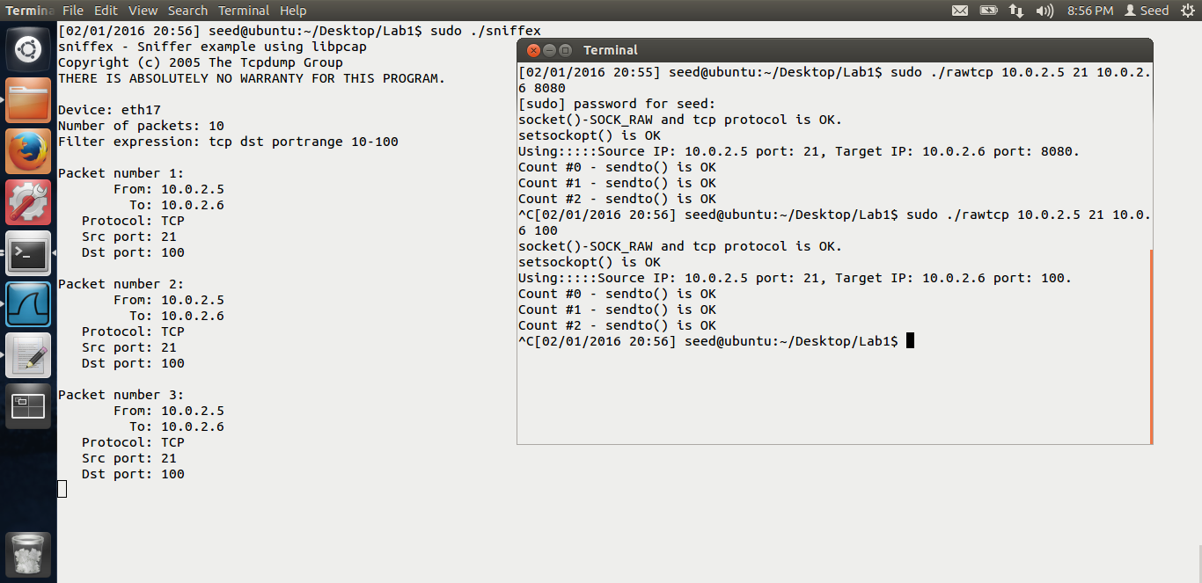

From the above screen shot, we can see that, I have opened 2 terminals, in 1 terminal I am running the sniifex program, in 2nd terminal, I am running the rawtcp to spoof tcp packets. First when I spoof tcp packet, with the destination as 8080 ( as seen in the screen shot), the packets are not captured by the program, but when I spoof tcp with destination port as 100, the packets are captured as seen from the output. Thus, the filter for tcp.

**Task 1.c: Sniffing passwords.**

When using telnet, passwords are sent as plain text. Hence, we can sniff those passwords. Also, telnet works on port 23. So if we use tcp and spoof on port 23, we should be able to see the password.

Let us see the filter expression for the same.

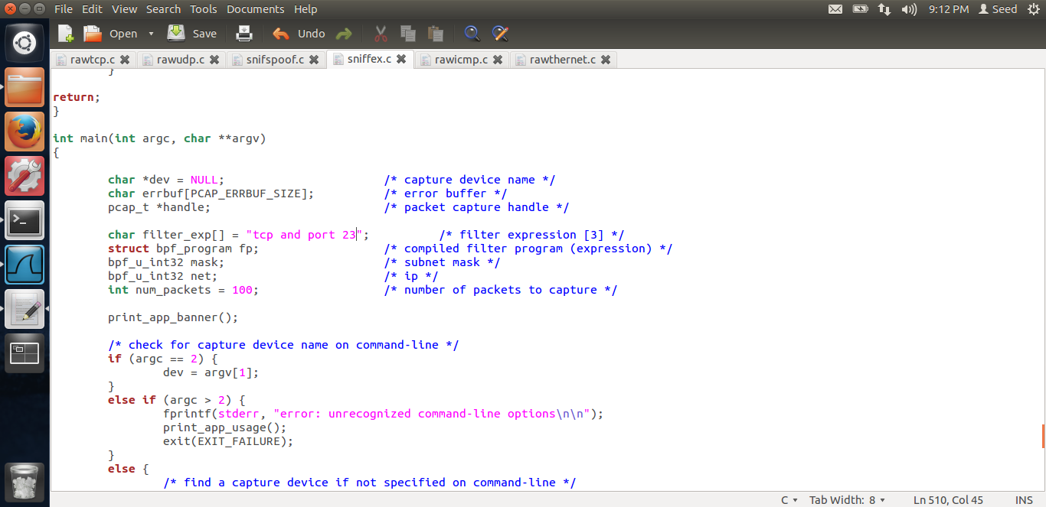

Thus, in the above expression, I changed the tcp and I am sniffing on port no 23, i.e. the telnet port.

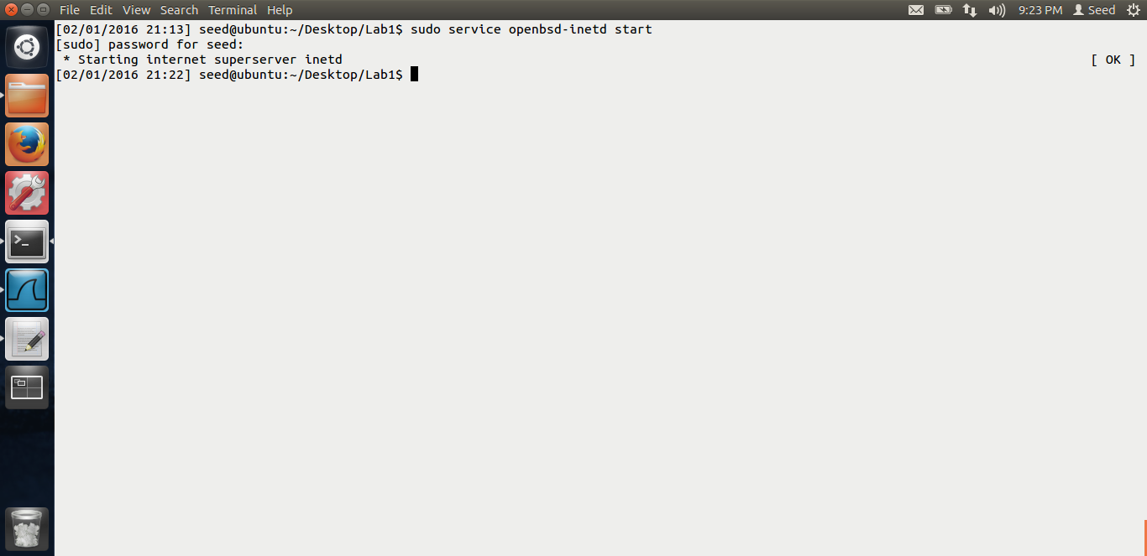

I start the telnet service on my original vm, as written in the lab description. I will telnet from my cloned vm to the original vm. And I will start my sniffer program on the original vm. Let us see the output.

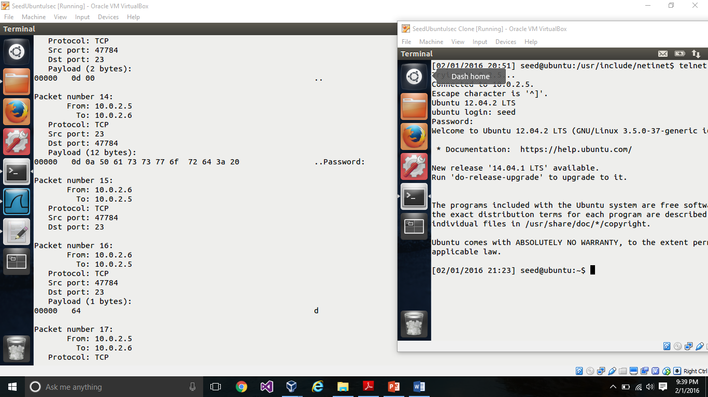

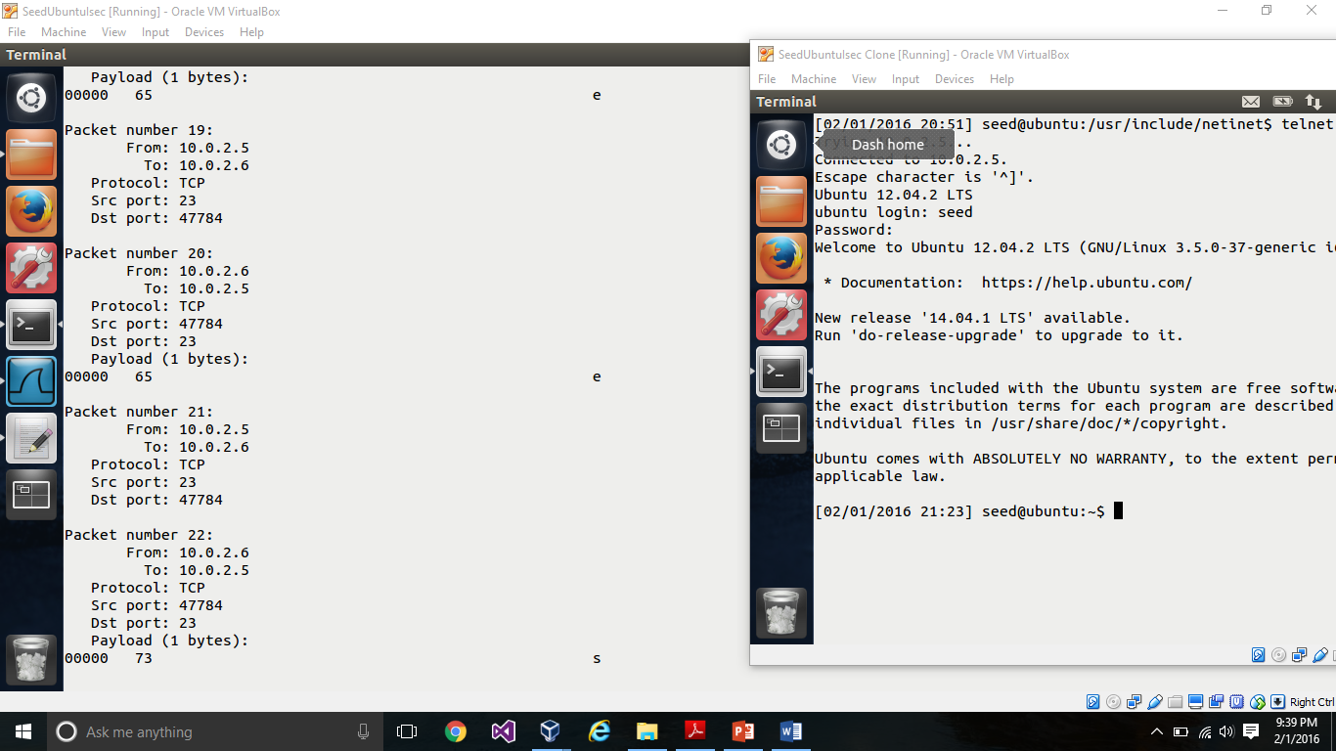

Thus, in the above screen shot, we see that, we are able to see the password in the packet, when we run the sniffex when the user enters the password on the clone vm. In the above screen shot, we get the password, d,e,e,s which is the password for seed. Thus I am successfully sniffing the password.

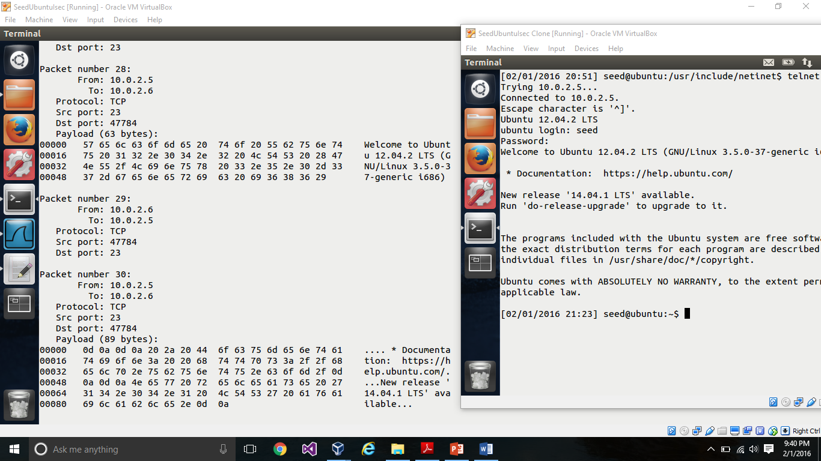

In the above screen shot, we just see rest of the information. Thus, I am able to successfully sniff the password.

# TASK 2: PACKET SPOOFING PROGRAM

Below are the screen shots for task 2 with the explanation.

UDP Spoofing program.

The UDP program I have made few changes to the program from the link Dr Du has provided on the website.

Below is the code:

// ----rawudp.c------

// Must be run by root lol! Just datagram, no payload/data

#include <unistd.h>

#include <stdio.h>

#include <sys/socket.h>

#include <netinet/ip.h>

#include <netinet/udp.h>

// The packet length

#define PCKT_LEN 8192

// Can create separate header file (.h) for all headers' structure

// The IP header's structure

struct ipheader {

unsigned char iph_ihl:4, iph_ver:4;

unsigned char iph_tos;

unsigned short int iph_len;

unsigned short int iph_ident;

unsigned short int iph_flags:4, iph_offset:12;

unsigned char iph_ttl;

unsigned char iph_protocol;

unsigned short int iph_chksum;

unsigned int iph_sourceip;

unsigned int iph_destip;

};

// UDP header's structure

struct udpheader {

unsigned short int udph_srcport;

unsigned short int udph_destport;

unsigned short int udph_len;

unsigned short int udph_chksum;

};

// total udp header length: 8 bytes (=64 bits)

// Function for checksum calculation. From the RFC,

// the checksum algorithm is:

// "The checksum field is the 16 bit one's complement of the one's

// complement sum of all 16 bit words in the header. For purposes of

// computing the checksum, the value of the checksum field is zero."

unsigned short csum(unsigned short *buf, int nwords)

{ //

unsigned long sum;

for(sum=0; nwords>0; nwords--)

sum += *buf++;

sum = (sum >> 16) + (sum &0xffff);

sum += (sum >> 16);

return (unsigned short)(~sum);

}

// Source IP, source port, target IP, target port from the command line arguments

int main(int argc, char *argv[])

{

int sd;

// No data/payload just datagram

char buffer[PCKT_LEN];

// Our own headers' structures

struct ipheader *ip = (struct ipheader *) buffer;

struct udpheader *udp = (struct udpheader *) (buffer + sizeof(struct ipheader));

// Source and destination addresses: IP and port

struct sockaddr_in sin, din;

int one = 1;

const int *val = &one;

memset(buffer, 0, PCKT_LEN);

if(argc != 5)

{

printf("- Invalid parameters!!!\n");

printf("- Usage %s <source hostname/IP> <source port> <target hostname/IP> <target port>\n", argv[0]);

exit(-1);

}

// Create a raw socket with UDP protocol

sd = socket(PF_INET, SOCK_RAW, IPPROTO_UDP);

if(sd < 0)

{

perror("socket() error");

// If something wrong just exit

exit(-1);

}

else

printf("socket() - Using SOCK_RAW socket and UDP protocol is OK.\n");

// The source is redundant, may be used later if needed

// The address family

sin.sin_family = AF_INET;

din.sin_family = AF_INET;

// Port numbers

sin.sin_port = htons(atoi(argv[2]));

din.sin_port = htons(atoi(argv[4]));

// IP addresses

sin.sin_addr.s_addr = inet_addr(argv[1]);

din.sin_addr.s_addr = inet_addr(argv[3]);

// Fabricate the IP header or we can use the

// standard header structures but assign our own values.

ip->iph_ihl = 5;

ip->iph_ver = 4;

ip->iph_tos = 16; // Low delay

ip->iph_len = sizeof(struct ipheader) + sizeof(struct udpheader);

ip->iph_ident = htons(54321);

ip->iph_ttl = 64; // hops

ip->iph_protocol = 17; // UDP

// Source IP address, can use spoofed address here!!!

ip->iph_sourceip = inet_addr(argv[1]);

// The destination IP address

ip->iph_destip = inet_addr(argv[3]);

// Fabricate the UDP header. Source port number, redundant

udp->udph_srcport = htons(atoi(argv[2]));

// Destination port number

udp->udph_destport = htons(atoi(argv[4]));

udp->udph_len = htons(sizeof(struct udpheader));

// Calculate the checksum for integrity

ip->iph_chksum = csum((unsigned short *)buffer, sizeof(struct ipheader) + sizeof(struct udpheader));

// Inform the kernel do not fill up the packet structure. we will build our own...

if(setsockopt(sd, IPPROTO_IP, IP_HDRINCL, val, sizeof(one)) < 0)

{

perror("setsockopt() error");

exit(-1);

}

else

printf("setsockopt() is OK.\n");

// Send loop, send for every 2 second for 100 count

printf("Trying...\n");

printf("Using raw socket and UDP protocol\n");

printf("Using Source IP: %s port: %u, Target IP: %s port: %u.\n", argv[1], atoi(argv[2]), argv[3], atoi(argv[4]));

int count;

for(count = 1; count <=20; count++)

{

if(sendto(sd, buffer, ip->iph_len, 0, (struct sockaddr *)&din, sizeof(din)) < 0)

// Verify

{

perror("sendto() error");

exit(-1);

}

else

{

printf("Count #%u - sendto() is OK.\n", count);

sleep(2);

}

}

close(sd);

return 0;

}

In the above code, the main places which I have made changes is, 1 is the ip header.

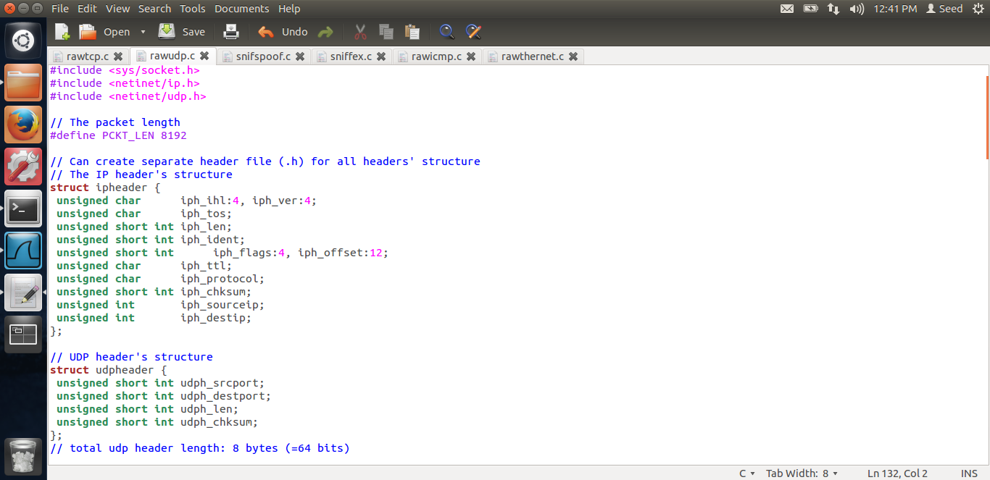

The ip header in the original program was more than 20 bytes, in the above screen shot, I have made it 20 bytes by changing the structure of the header. Next, in the sendto() function, originally, the send to was sending to the source socket only, I changed it to the destination socket.

Below is the output. 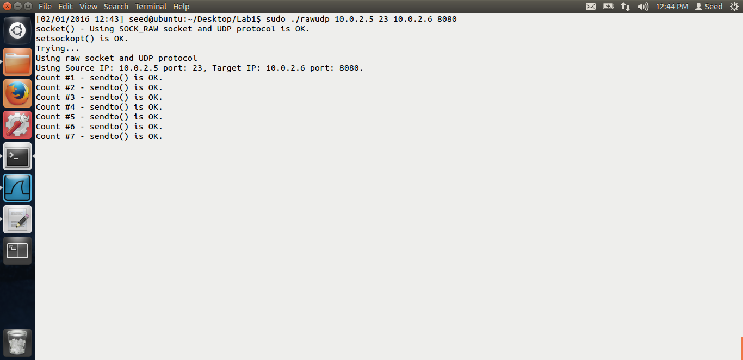

From the above screen shot, we can see that I am running the rawudp program, with source as 10.0.2.5 port as 23 and the destination as 10.0.2.6 and port as 8080, The output looks good. Let us look at wireshark.

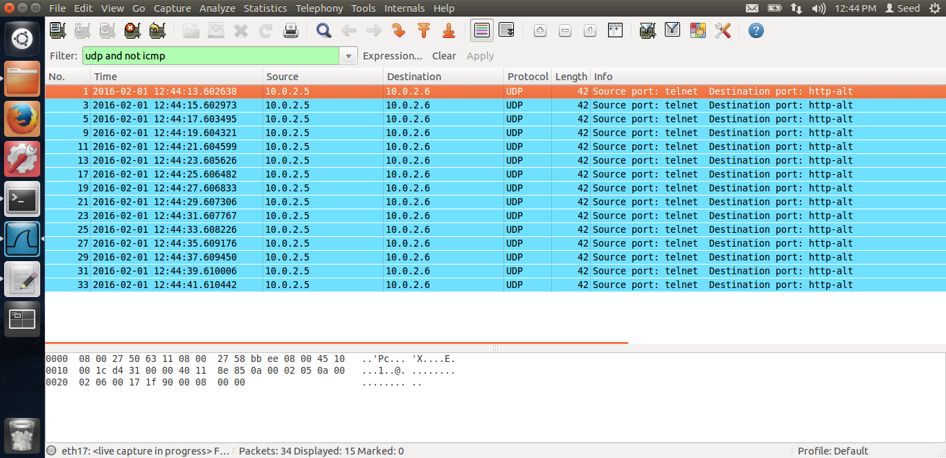

This is the output for wireshark. We can see that from the output, the source is 10.0.2.5 and destination is 10.0.2.6, protocol is UDP. Thus, I have successfully spoofed UDP program.

Spoofing TCP program.

The TCP program is also the one from the link given by Dr. Du. I have made few changes to the code. Below is the code.

#include <unistd.h>

#include <stdio.h>

#include <sys/socket.h>

#include <netinet/ip.h>

#include <netinet/tcp.h>

// Packet length

#define PCKT_LEN 8192

// May create separate header file (.h) for all

// headers' structures

// IP header's structure

struct ipheader {

unsigned char iph_ihl:4, /* Little-endian */

iph_ver:4;

unsigned char iph_tos;

unsigned short int iph_len;

unsigned short int iph_ident;

unsigned short int iph_flags:4, iph_offset:12;

unsigned char iph_ttl;

unsigned char iph_protocol;

unsigned short int iph_chksum;

unsigned int iph_sourceip;

unsigned int iph_destip;

};

/* Structure of a TCP header */

struct tcpheader {

unsigned short int tcph_srcport;

unsigned short int tcph_destport;

unsigned int tcph_seqnum;

unsigned int tcph_acknum;

unsigned char tcph_reserved:4, tcph_offset:4;

// unsigned char tcph_flags;

unsigned char /*length of tcp header in 32-bit words*/

tcph_fin:1, /*Finish flag "fin"*/

tcph_syn:1, /*Synchronize sequence numbers to start a connection*/

tcph_rst:1, /*Reset flag */

tcph_psh:1, /*Push, sends data to the application*/

tcph_ack:1, /*acknowledge*/

tcph_urg:1; /*urgent pointer*/

unsigned short int tcph_win;

unsigned short int tcph_chksum;

unsigned short int tcph_urgptr;

};

// Simple checksum function, may use others such as Cyclic Redundancy Check, CRC

unsigned short csum(unsigned short *buf, int len)

{

unsigned long sum;

for(sum=0; len>0; len--)

sum += *buf++;

sum = (sum >> 16) + (sum &0xffff);

sum += (sum >> 16);

return (unsigned short)(~sum);

}

int main(int argc, char *argv[])

{

int sd;

// No data, just datagram

char buffer[PCKT_LEN];

// The size of the headers

struct ipheader *ip = (struct ipheader *) buffer;

struct tcpheader *tcp = (struct tcpheader *) (buffer + sizeof(struct ipheader));

struct sockaddr_in sin, din;

int one = 1;

const int *val = &one;

memset(buffer, 0, PCKT_LEN);

if(argc != 5)

{

printf("- Invalid parameters!!!\n");

printf("- Usage: %s <source hostname/IP> <source port> <target hostname/IP> <target port>\n", argv[0]);

exit(-1);

}

sd = socket(PF_INET, SOCK_RAW, IPPROTO_TCP);

if(sd < 0)

{

perror("socket() error");

exit(-1);

}

else

printf("socket()-SOCK_RAW and tcp protocol is OK.\n");

// The source is redundant, may be used later if needed

// Address family

sin.sin_family = AF_INET;

din.sin_family = AF_INET;

// Source port, can be any, modify as needed

sin.sin_port = htons(atoi(argv[2]));

din.sin_port = htons(atoi(argv[4]));

// Source IP, can be any, modify as needed

sin.sin_addr.s_addr = inet_addr(argv[1]);

din.sin_addr.s_addr = inet_addr(argv[3]);

// IP structure

ip->iph_ihl = 5;

ip->iph_ver = 4;

ip->iph_tos = 16;

ip->iph_len = sizeof(struct ipheader) + sizeof(struct tcpheader);

ip->iph_ident = htons(54321);

ip->iph_offset = 0;

ip->iph_ttl = 64;

ip->iph_protocol = 6; // TCP

ip->iph_chksum = 0; // Done by kernel

// Source IP, modify as needed, spoofed, we accept through command line argument

ip->iph_sourceip = inet_addr(argv[1]);

// Destination IP, modify as needed, but here we accept through command line argument

ip->iph_destip = inet_addr(argv[3]);

// The TCP structure. The source port, spoofed, we accept through the command line

tcp->tcph_srcport = htons(atoi(argv[2]));

// The destination port, we accept through command line

tcp->tcph_destport = htons(atoi(argv[4]));

tcp->tcph_seqnum = 1;

tcp->tcph_acknum = 0;

tcp->tcph_offset = 5;

tcp->tcph_syn = 1;

tcp->tcph_ack = 0;

tcp->tcph_win = htons(32767);

tcp->tcph_chksum = 0; // Done by kernel

tcp->tcph_urgptr = 0;

// IP checksum calculation

ip->iph_chksum = csum((unsigned short *) buffer, (sizeof(struct ipheader) + sizeof(struct tcpheader)));

// Inform the kernel do not fill up the headers' structure, we fabricated our own

if(setsockopt(sd, IPPROTO_IP, IP_HDRINCL, val, sizeof(one)) < 0)

{

perror("setsockopt() error");

exit(-1);

}

else

printf("setsockopt() is OK\n");

printf("Using:::::Source IP: %s port: %u, Target IP: %s port: %u.\n", argv[1], atoi(argv[2]), argv[3], atoi(argv[4]));

// sendto() loop, send every 2 second for 50 counts

unsigned int count;

for(count = 0; count < 20; count++)

{

if(sendto(sd, buffer, ip->iph_len, 0, (struct sockaddr *)&din, sizeof(din)) < 0)

// Verify

{

perror("sendto() error");

exit(-1);

}

else

printf("Count #%u - sendto() is OK\n", count);

sleep(2);

}

close(sd);

return 0;

}

The main changes I have made is, is to the tcp header structure. And the ip header structure.

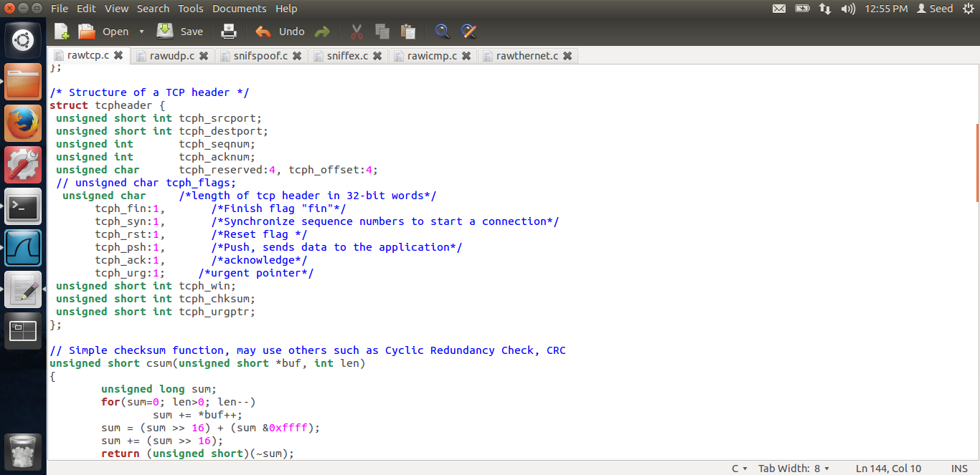

In the above screen shot, we can see that I have changed the tcp structure, I have made it 20 bytes and the tcp header is 20 bytes. I have changed the reserved and offset to be 4 bits respectively. Also, for the flags, I have changed the data type to be char, i.e. 1 byte, thus overall the structure is 20 bytes. The ip header and the sendto() function changes are the same as UDP changes, rest of the things in the code has not been changed. Let us see the output.

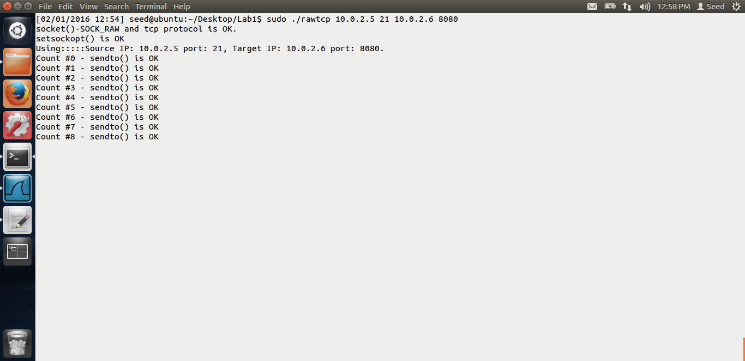

In the above screen shot, we can see that I am running the program, same source and destination, src as 10.0.2.5 and destination as 10.0.2.6, The output looks good. Let us look at the wireshark.

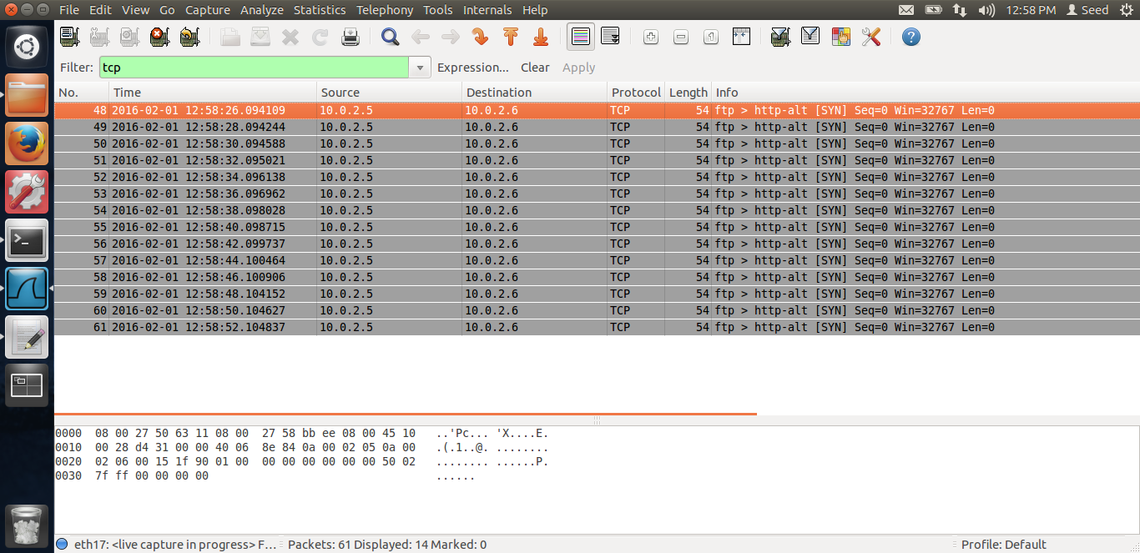

Above is the screen shot of wireshark. We can see the tcp packets being spoofed from 10.0.2.5 to 10.0.2.6, the color is grey. Thus, I have successfully spoofed the TCP packets.

**Question 4:** Can we set the IP packet length to any arbitrary value?

Yes, we can set the IP packet length to any arbitrary value.

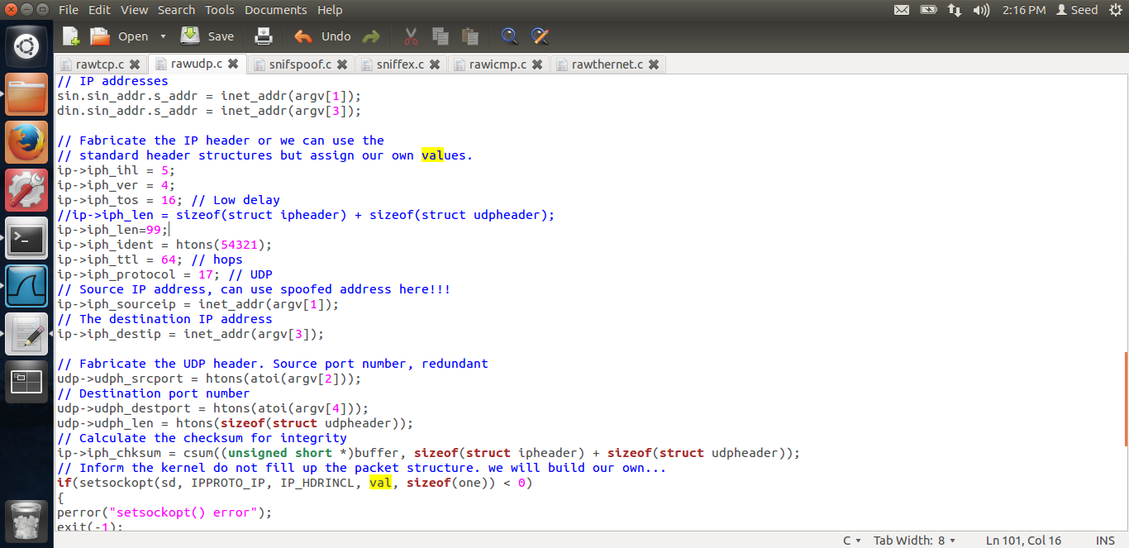

In the above screen shot, I changed the ip->len field to 99 and compiled the code.

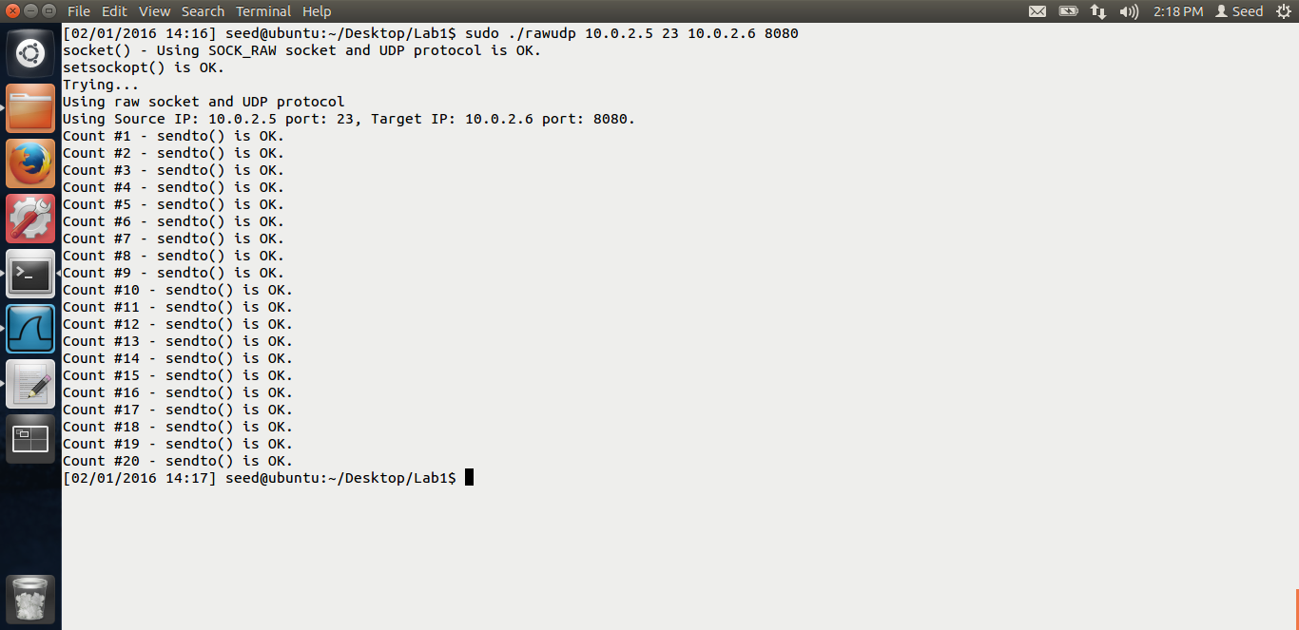

I run the code, it works fine. Let us see the wireshark output.

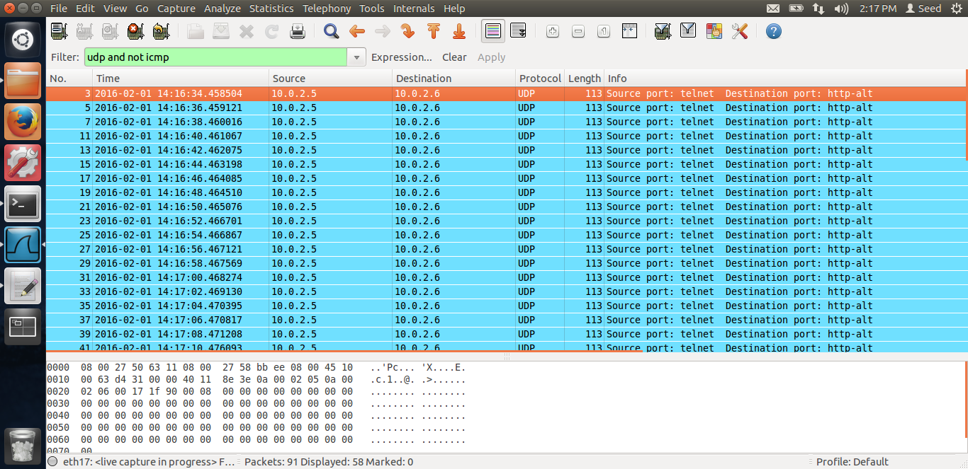

Here, we can see the packets are sent, the total length is 113, thus, we can set any arbitrary value to the length field.

**Question 5:** Do we have to calculate the checksum.?

No. Even though in the program we are calculating the checksum, even if we don’t calculate the checksum, the kernel will calculate the checksum for us and send the packet.

**Question 6:** Do we need to root priviledge ro run the program?

Yes, we need root privilege to run the raw socket programs. If the program is not run using the root privilege, the program fails.

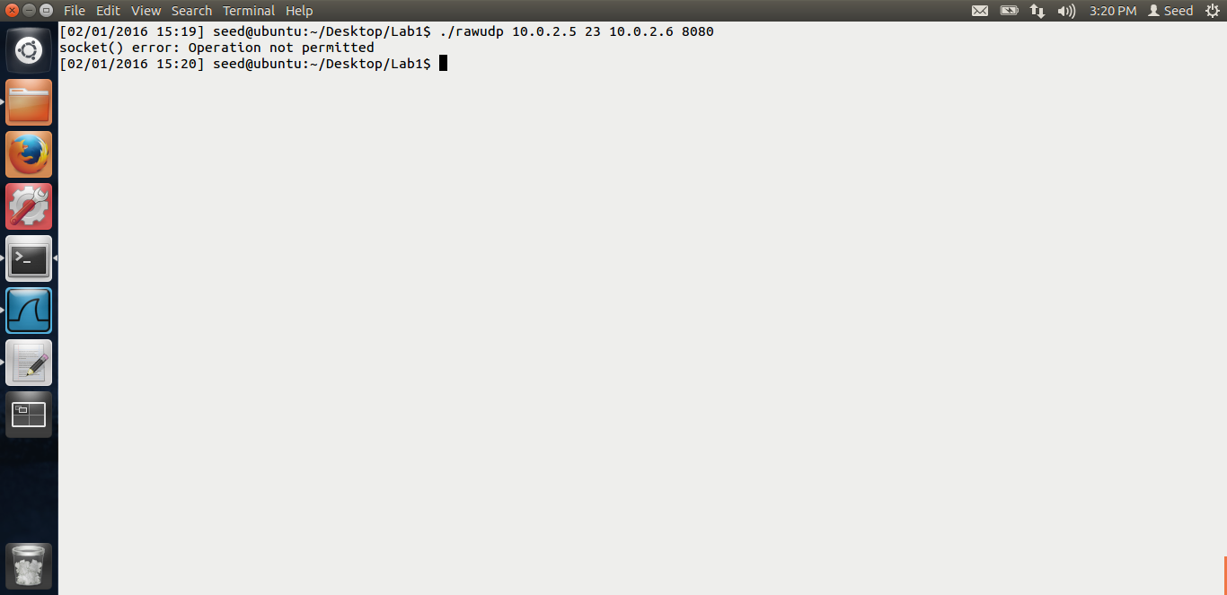

In the above screen shot, I tried running the rawudp program without the root privilege. From the screen shot, we can see that we get the error, socket() operation not permitted. Thus, root privilege is necessary to use raw sockets.

**Task 2.b Spoof an ICMP echo request.**

The screen shots and explanation for spoofing an ICMP echo request is below.

In this task, I have to spoof an ICMP request on behalf of another machine to any machine on the internet. Thus, my spoofing ICMP program, rawicmp.c is on my original vm. I am going to spoof the icmp request from the clone vm, i.e. with the ip 10.0.2.6 and going to ping to google.com

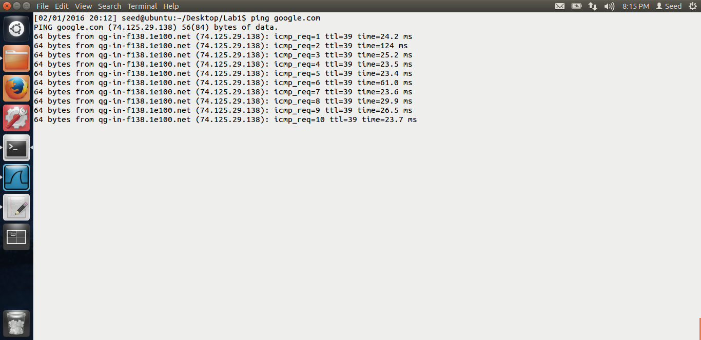

In the above screen shot, I am pinging google.com. We can see that the server I hit has the ip 74.125.29.138. This ping I am doing from my original vm. Just to get the ip of google.com

In the wireshark, the output is,

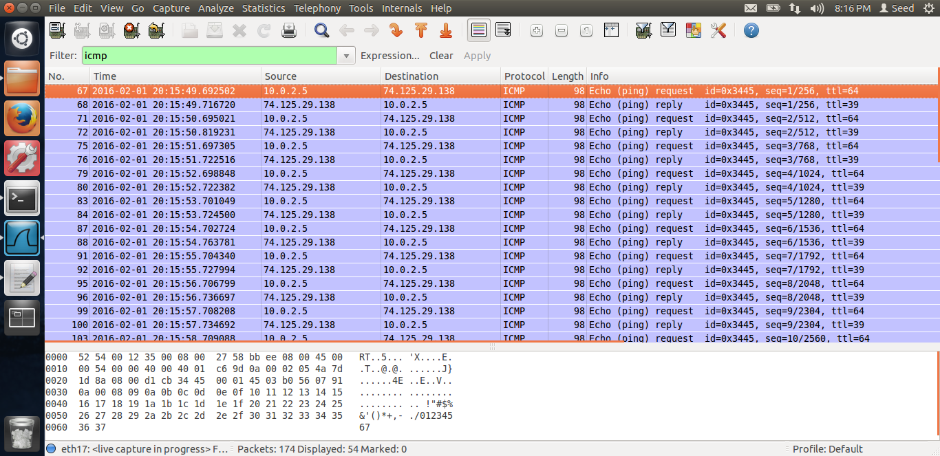

We can see the source is 10.0.2.5 and destination is 74.125.29.138. In wireshark we can see both the request and the reply.

Now, below is the code for my rawicmp.c I have taken the rawudp code and modified it. Instead of udp header, I am using the icmphdr struct. The code is as below.

// ----rawicmp.c------

// Must be run by root lol! Just datagram, no payload/data

#include <stdio.h>

#include <stdlib.h>

#include <unistd.h> // close()

#include <string.h> // strcpy, memset(), and memcpy()

#include <netdb.h> // struct addrinfo

#include <sys/types.h> // needed for socket(), uint8_t, uint16_t, uint32_t

#include <sys/socket.h> // needed for socket()

#include <netinet/in.h> // IPPROTO_RAW, IPPROTO_IP, IPPROTO_ICMP, INET_ADDRSTRLEN

#include <netinet/ip.h> // struct ip and IP_MAXPACKET (which is 65535)

#include <netinet/ip_icmp.h> // struct icmp, ICMP_ECHO

#include <arpa/inet.h> // inet_pton() and inet_ntop()

#include <sys/ioctl.h> // macro ioctl is defined

#include <bits/ioctls.h> // defines values for argument "request" of ioctl.

#include <net/if.h> // struct ifreq

#include <errno.h> // errno, perror()

// The packet length

#define PCKT_LEN 8192

// Can create separate header file (.h) for all headers' structure

// The IP header's structure

struct ipheader {

unsigned char iph_ihl:4, iph_ver:4;

unsigned char iph_tos;

unsigned short int iph_len;

unsigned short int iph_ident;

unsigned short int iph_flags:4, iph_offset:12;

unsigned char iph_ttl;

unsigned char iph_protocol;

unsigned short int iph_chksum;

unsigned int iph_sourceip;

unsigned int iph_destip;

};

unsigned short in_cksum(unsigned short *addr, int len)

{

int count = len;

register uint32_t sum = 0;

uint16_t answer = 0;

// Sum up 2-byte values until none or only one byte left.

while (count > 1) {

sum += *(addr++);

count -= 2;

}

// Add left-over byte, if any.

if (count > 0) {

sum += *(uint8_t *) addr;

}

// Fold 32-bit sum into 16 bits; we lose information by doing this,

// increasing the chances of a collision.

// sum = (lower 16 bits) + (upper 16 bits shifted right 16 bits)

while (sum >> 16) {

sum = (sum & 0xffff) + (sum >> 16);

}

// Checksum is one's compliment of sum.

answer = ~sum;

return (answer);

}

unsigned short csum(unsigned short *buf, int nwords)

{ //

unsigned long sum;

for(sum=0; nwords>0; nwords--)

sum += *buf++;

sum = (sum >> 16) + (sum &0xffff);

sum += (sum >> 16);

return (unsigned short)(~sum);

}

// Source IP, source port, target IP, target port from the command line arguments

int main(int argc, char *argv[])

{

int sd;

// No data/payload just datagram

char buffer[PCKT_LEN];

// Our own headers' structures

struct ipheader *ip = (struct ipheader *) buffer;

struct icmphdr *icmp = (struct icmphdr *) (buffer + sizeof(struct ipheader));

// Source and destination addresses: IP and port

struct sockaddr_in sin, din;

int one = 1;

const int *val = &one;

memset(buffer, 0, PCKT_LEN);

if(argc != 3)

{

printf("- Invalid parameters!!!\n");

printf("- Usage %s <source hostname/IP> <target hostname/IP> \n", argv[0]);

exit(-1);

}

// Create a raw socket with UDP protocol

sd = socket(PF_INET, SOCK_RAW, IPPROTO_ICMP);

if(sd < 0)

{

perror("socket() error");

// If something wrong just exit

exit(-1);

}

else

printf("socket() - Using SOCK_RAW socket and ICMP protocol is OK.\n");

// The source is redundant, may be used later if needed

// The address family

sin.sin_family = AF_INET;

din.sin_family = AF_INET;

// Port numbers

//sin.sin_port = htons(atoi(argv[2]));

//din.sin_port = htons(atoi(argv[4]));

// IP addresses

sin.sin_addr.s_addr = inet_addr(argv[1]);

din.sin_addr.s_addr = inet_addr(argv[2]);

// Fabricate the IP header or we can use the

// standard header structures but assign our own values.

ip->iph_ihl = 5;

ip->iph_ver = 4;

ip->iph_tos = 16; // Low delay

ip->iph_len = sizeof(struct ipheader) + sizeof(struct icmphdr);

//ip->iph_len=99;

ip->iph_ident = htons(54321);

ip->iph_ttl = 64; // hops

ip->iph_protocol = 1; // ICMP

// Source IP address, can use spoofed address here!!!

ip->iph_sourceip = inet_addr(argv[1]);

// The destination IP address

ip->iph_destip = inet_addr(argv[2]);

icmp->type=ICMP_ECHO;

icmp->code=0;

icmp->checksum=0;

icmp->checksum=htons(~(ICMP_ECHO << 8));

// Calculate the checksum for integrity

ip->iph_chksum = csum((unsigned short *)buffer,sizeof(struct ipheader) + sizeof(struct icmphdr));

// Inform the kernel do not fill up the packet structure. we will build our own...

if(setsockopt(sd, IPPROTO_IP, IP_HDRINCL, val, sizeof(one)) < 0)

{

perror("setsockopt() error");

exit(-1);

}

else

printf("setsockopt() is OK.\n");

// Send loop, send for every 2 second for 100 count

printf("Trying...\n");

printf("Using raw socket and ICMP protocol\n");

//printf("Using Source IP: %s port: %u, Target IP: %s port: %u.\n", argv[1], atoi(argv[2]), argv[3], atoi(argv[4]));

int count;

for(count = 1; count <=20; count++)

{

if(sendto(sd, buffer, ip->iph_len, 0, (struct sockaddr *)&din, sizeof(din)) < 0)

// Verify

{

perror("sendto() error");

exit(-1);

}

else

{

printf("Count #%u - sendto() is OK.\n", count);

sleep(2);

}

}

close(sd);

return 0;

}

In the above code, I have just substituted ICMP header, instead of UDP. The struct icmphdr is a struct in the C lib which I have used. The main code, where I am setting the ICMP fileds are,

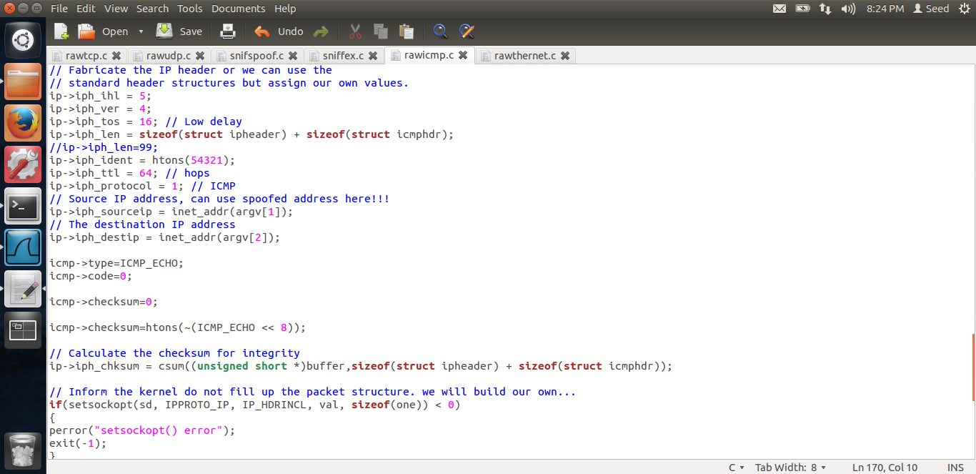

In the above screen shot, we can see that the ip->len I am setting as sizeof ipheader plus sizeof icmphdr. Then another change is that the iph->protocal value, I am setting it as 1, which is that of ICMP. Then, I am setting the fields for ICMP header. Icmp->type as ICMP_ECHO, code as 0, and the checksum as shown above. Also, the socket I have used is for ICMP packet,

sd = socket(PF_INET, SOCK_RAW, IPPROTO_ICMP);

After constructing all this, I am sending the packet. Let us see the output.

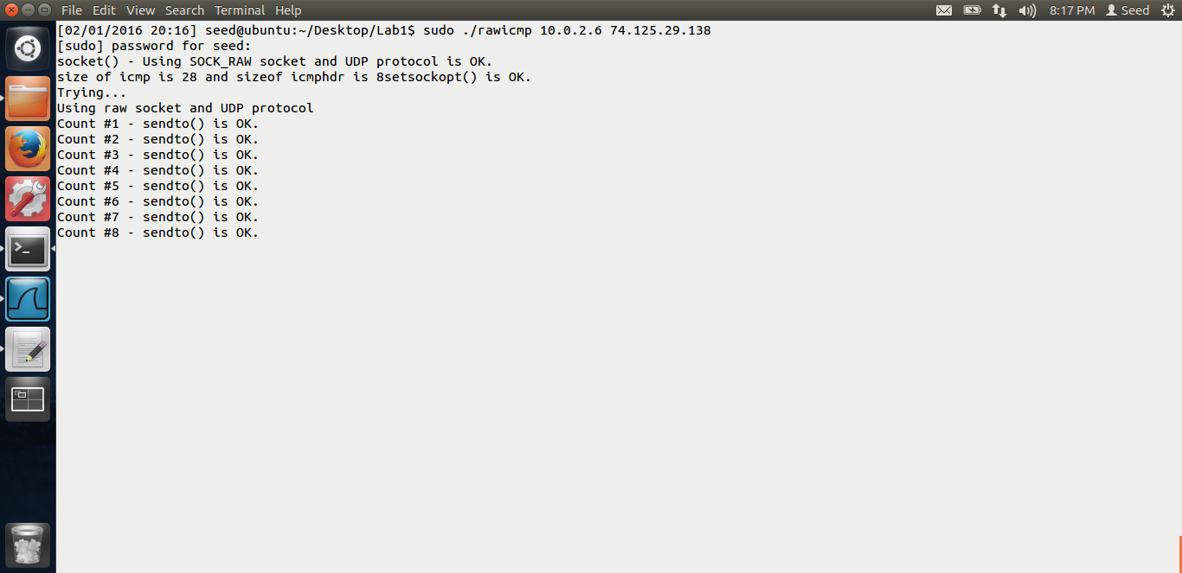

Thus, in the above screen shot, we can see that I am running the rawicmp program. The source ip I am putting is that of the clone vm, i.e. 10.0.2.6 and the destination ip is that of google, i.e. 74.125.29.138. Thus in the above, we see that the code is running properly. Let us see the output in wireshark.

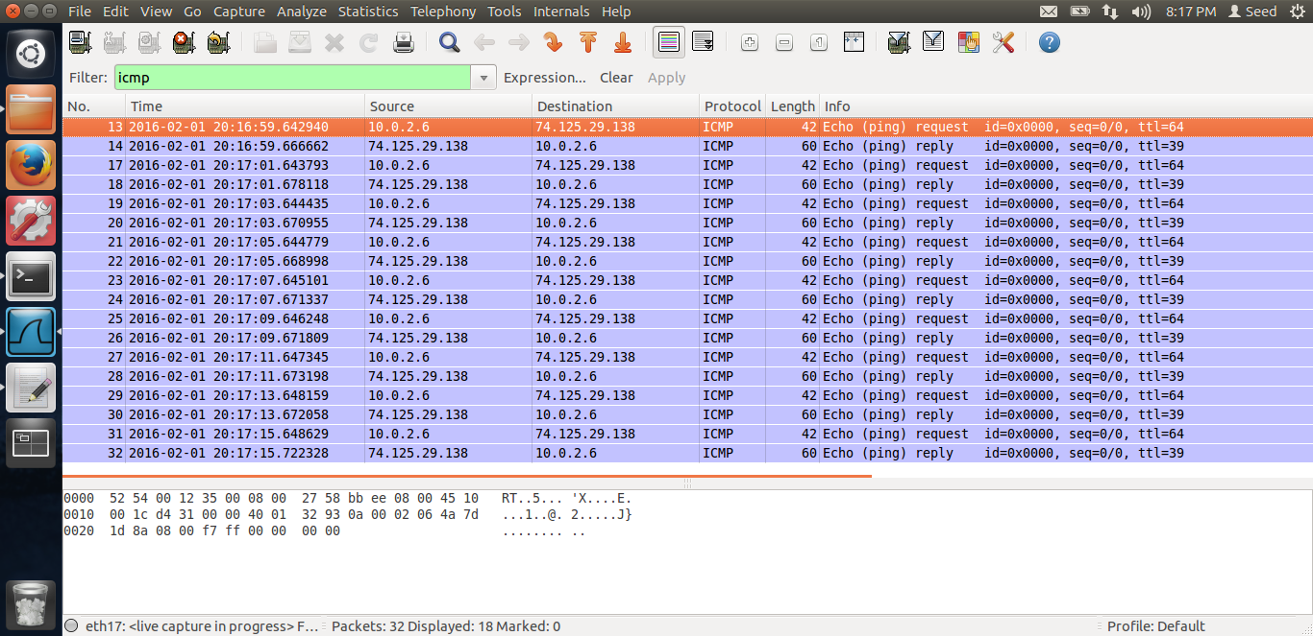

In the wireshark also, we can see that, ICMP packets are being spoofed. The source is 10.0.2.6 and the destination ip is that of google. Thus we see both the request and the reply. Thus I have completed ICMP spoofing.

**Task 2.c Spoof an Ethernet Frame.**

This is the program I referred to from net. It sends an Ethernet frame, but without any IP or other header. Let me run the program and show the output.

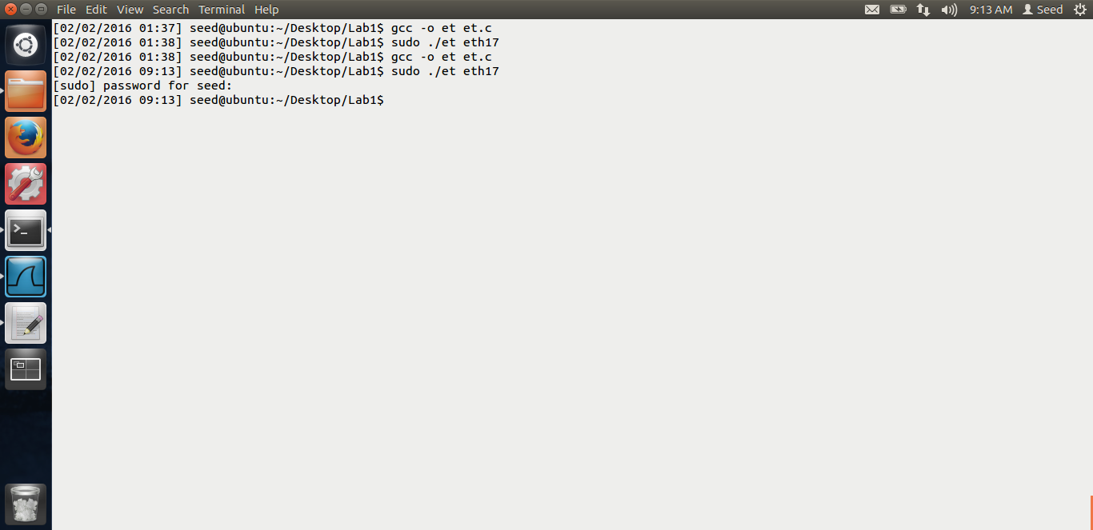

The output in wireshark is,

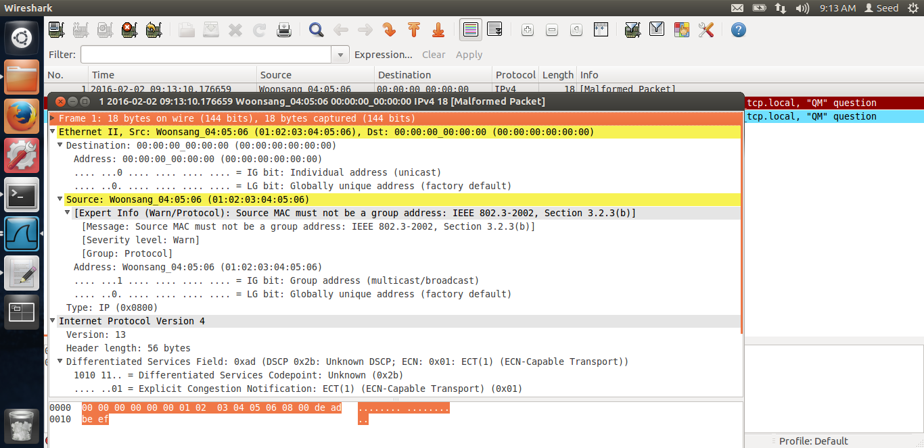

You can see the source port is 01:02:03:04:05:06, which I set as per the lab description, the destination is just 00:00:00:00:00:00.

The code is below.

#include <arpa/inet.h>

#include <linux/if_packet.h>

#include <stdio.h>

#include <string.h>

#include <stdlib.h>

#include <sys/ioctl.h>

#include <sys/socket.h>

#include <net/if.h>

#include <netinet/ether.h>

#define MY_DEST_MAC0 0x00

#define MY_DEST_MAC1 0x00

#define MY_DEST_MAC2 0x00

#define MY_DEST_MAC3 0x00

#define MY_DEST_MAC4 0x00

#define MY_DEST_MAC5 0x00

#define DEFAULT_IF "eth17"

#define BUF_SIZ 1024

int main(int argc, char *argv[])

{

int sockfd;

struct ifreq if_idx;

struct ifreq if_mac;

int tx_len = 0;

char sendbuf[BUF_SIZ];

struct ether_header *eh = (struct ether_header *) sendbuf;

struct iphdr *iph = (struct iphdr *) (sendbuf + sizeof(struct ether_header));

struct sockaddr_ll socket_address;

char ifName[IFNAMSIZ];

/* Get interface name */

if (argc > 1)

strcpy(ifName, argv[1]);

else

strcpy(ifName, DEFAULT_IF);

/* Open RAW socket to send on */

if ((sockfd = socket(AF_PACKET, SOCK_RAW, IPPROTO_RAW)) == -1) {

perror("socket");

}

/* Get the index of the interface to send on */

memset(&if_idx, 0, sizeof(struct ifreq));

strncpy(if_idx.ifr_name, ifName, IFNAMSIZ-1);

if (ioctl(sockfd, SIOCGIFINDEX, &if_idx) < 0)

perror("SIOCGIFINDEX");

/* Get the MAC address of the interface to send on */

memset(&if_mac, 0, sizeof(struct ifreq));

strncpy(if_mac.ifr_name, ifName, IFNAMSIZ-1);

if (ioctl(sockfd, SIOCGIFHWADDR, &if_mac) < 0)

perror("SIOCGIFHWADDR");

/* Construct the Ethernet header */

memset(sendbuf, 0, BUF_SIZ);

/* Ethernet header */

eh->ether_shost[0] = 0x01;

eh->ether_shost[1] = 0x02;

eh->ether_shost[2] = 0x03;

eh->ether_shost[3] = 0x04;

eh->ether_shost[4] = 0x05;

eh->ether_shost[5] = 0x06;

eh->ether_dhost[0] = MY_DEST_MAC0;

eh->ether_dhost[1] = MY_DEST_MAC1;

eh->ether_dhost[2] = MY_DEST_MAC2;

eh->ether_dhost[3] = MY_DEST_MAC3;

eh->ether_dhost[4] = MY_DEST_MAC4;

eh->ether_dhost[5] = MY_DEST_MAC5;

/* Ethertype field */

eh->ether_type = htons(ETH_P_IP);

tx_len += sizeof(struct ether_header);

/* Packet data */

sendbuf[tx_len++] = 0xde;

sendbuf[tx_len++] = 0xad;

sendbuf[tx_len++] = 0xbe;

sendbuf[tx_len++] = 0xef;

/* Index of the network device */

socket_address.sll_ifindex = if_idx.ifr_ifindex;

/* Address length*/

socket_address.sll_halen = ETH_ALEN;

/* Destination MAC */

socket_address.sll_addr[0] = MY_DEST_MAC0;

socket_address.sll_addr[1] = MY_DEST_MAC1;

socket_address.sll_addr[2] = MY_DEST_MAC2;

socket_address.sll_addr[3] = MY_DEST_MAC3;

socket_address.sll_addr[4] = MY_DEST_MAC4;

socket_address.sll_addr[5] = MY_DEST_MAC5;

/* Send packet */

if (sendto(sockfd, sendbuf, tx_len, 0, (struct sockaddr*)&socket_address, sizeof(struct sockaddr_ll)) < 0)

printf("Send failed\n");

return 0;

}

First, its defining all the destination mac bits, then creating a socket,Then its creating a

Sockaddr_ll struct variable, opening the raw socket, getting the interface details on which to send, and then filing up the data, i.e. source and destination mac and sending the packet. Thus I am spoofing Ethernet frame.

# TASK 3: SNIFFING AND SPOOFING

The screen shot for task 3 are below with the explanation.

In thie task, the sniffer and spoofing program is on my original vm. I am going to ping a IP-X from the clone VM. As the ip X is not present, ideally, the clone vm should not get the reply. But because of my program, the clone VM will get a reply.

Initial set-up. The spoofed ip I am going to test is 10.0.2.10. This machine does not exists in the network. Hence, I have to run the command, sudo arp –s 10.0.2.10 AA:AA:AA:AA:AA:AA

This is because, when we ping a non-existing IP in the same network, an ARP request is sent first. If there is no reply, ICMP request is not sent later. Thus, to avoid the ARP request, we run the above command as given in the guidelines of the lab.

After this is done, let me paste the code below. The code is the same as that of sniffex.c The only changes I have made is in the switch case when the protocol is ICMP. Rest of the code is same of sniffex. Let me paste the code first.

#define APP_NAME "sniffex"

#define APP_DESC "Sniffer example using libpcap"

#define APP_COPYRIGHT "Copyright (c) 2005 The Tcpdump Group"

#define APP_DISCLAIMER "THERE IS ABSOLUTELY NO WARRANTY FOR THIS PROGRAM."

#include <pcap.h>

#include <stdio.h>

#include <string.h>

#include <stdlib.h>

#include <ctype.h>

#include <unistd.h> // close()

#include <netdb.h> // struct addrinfo

#include <sys/types.h> // needed for socket(), uint8_t, uint16_t, uint32_t

#include <sys/socket.h> // needed for socket()

#include <netinet/in.h> // IPPROTO_RAW, IPPROTO_IP, IPPROTO_ICMP, INET_ADDRSTRLEN

#include <netinet/ip.h> // struct ip and IP_MAXPACKET (which is 65535)

#include <netinet/ip_icmp.h> // struct icmp, ICMP_ECHO

#include <arpa/inet.h> // inet_pton() and inet_ntop()

#include <sys/ioctl.h> // macro ioctl is defined

#include <bits/ioctls.h> // defines values for argument "request" of ioctl.

#include <net/if.h> // struct ifreq

#include <errno.h> // errno, perror()

/* default snap length (maximum bytes per packet to capture) */

#define SNAP_LEN 1518

/* ethernet headers are always exactly 14 bytes [1] */

#define SIZE_ETHERNET 14

/* Ethernet addresses are 6 bytes */

#define ETHER_ADDR_LEN 6

/* Ethernet header */

struct sniff_ethernet {

u_char ether_dhost[ETHER_ADDR_LEN]; /* destination host address */

u_char ether_shost[ETHER_ADDR_LEN]; /* source host address */

u_short ether_type; /* IP? ARP? RARP? etc */

};

/* IP header */

struct sniff_ip {

u_char ip_vhl; /* version << 4 | header length >> 2 */

u_char ip_tos; /* type of service */

u_short ip_len; /* total length */

u_short ip_id; /* identification */

u_short ip_off; /* fragment offset field */

#define IP_RF 0x8000 /* reserved fragment flag */

#define IP_DF 0x4000 /* dont fragment flag */

#define IP_MF 0x2000 /* more fragments flag */

#define IP_OFFMASK 0x1fff /* mask for fragmenting bits */

u_char ip_ttl; /* time to live */

u_char ip_p; /* protocol */

u_short ip_sum; /* checksum */

struct in_addr ip_src,ip_dst; /* source and dest address */

};

#define IP_HL(ip) (((ip)->ip_vhl) & 0x0f)

#define IP_V(ip) (((ip)->ip_vhl) >> 4)

/* TCP header */

typedef u_int tcp_seq;

struct sniff_tcp {

u_short th_sport; /* source port */

u_short th_dport; /* destination port */

tcp_seq th_seq; /* sequence number */

tcp_seq th_ack; /* acknowledgement number */

u_char th_offx2; /* data offset, rsvd */

#define TH_OFF(th) (((th)->th_offx2 & 0xf0) >> 4)

u_char th_flags;

#define TH_FIN 0x01

#define TH_SYN 0x02

#define TH_RST 0x04

#define TH_PUSH 0x08

#define TH_ACK 0x10

#define TH_URG 0x20

#define TH_ECE 0x40

#define TH_CWR 0x80

#define TH_FLAGS (TH_FIN|TH_SYN|TH_RST|TH_ACK|TH_URG|TH_ECE|TH_CWR)

u_short th_win; /* window */

u_short th_sum; /* checksum */

u_short th_urp; /* urgent pointer */

};

void

got_packet(u_char *args, const struct pcap_pkthdr *header, const u_char *packet);

void

print_payload(const u_char *payload, int len);

void

print_hex_ascii_line(const u_char *payload, int len, int offset);

void

print_app_banner(void);

void

print_app_usage(void);

/*

* app name/banner

*/

void

print_app_banner(void)

{

printf("%s - %s\n", APP_NAME, APP_DESC);

printf("%s\n", APP_COPYRIGHT);

printf("%s\n", APP_DISCLAIMER);

printf("\n");

return;

}

/*

* print help text

*/

void

print_app_usage(void)

{

printf("Usage: %s [interface]\n", APP_NAME);

printf("\n");

printf("Options:\n");

printf(" interface Listen on <interface> for packets.\n");

printf("\n");

return;

}

/*

* print data in rows of 16 bytes: offset hex ascii

*

* 00000 47 45 54 20 2f 20 48 54 54 50 2f 31 2e 31 0d 0a GET / HTTP/1.1..

*/

void

print_hex_ascii_line(const u_char *payload, int len, int offset)

{

int i;

int gap;

const u_char *ch;

/* offset */

printf("%05d ", offset);

/* hex */

ch = payload;

for(i = 0; i < len; i++) {

printf("%02x ", *ch);

ch++;

/* print extra space after 8th byte for visual aid */

if (i == 7)

printf(" ");

}

/* print space to handle line less than 8 bytes */

if (len < 8)

printf(" ");

/* fill hex gap with spaces if not full line */

if (len < 16) {

gap = 16 - len;

for (i = 0; i < gap; i++) {

printf(" ");

}

}

printf(" ");

/* ascii (if printable) */

ch = payload;

for(i = 0; i < len; i++) {

if (isprint(*ch))

printf("%c", *ch);

else

printf(".");

ch++;

}

printf("\n");

return;

}

/*

* print packet payload data (avoid printing binary data)

*/

void

print_payload(const u_char *payload, int len)

{

int len_rem = len;

int line_width = 16; /* number of bytes per line */

int line_len;

int offset = 0; /* zero-based offset counter */

const u_char *ch = payload;

if (len <= 0)

return;

/* data fits on one line */

if (len <= line_width) {

print_hex_ascii_line(ch, len, offset);

return;

}

/* data spans multiple lines */

for ( ;; ) {

/* compute current line length */

line_len = line_width % len_rem;

/* print line */

print_hex_ascii_line(ch, line_len, offset);

/* compute total remaining */

len_rem = len_rem - line_len;

/* shift pointer to remaining bytes to print */

ch = ch + line_len;

/* add offset */

offset = offset + line_width;

/* check if we have line width chars or less */

if (len_rem <= line_width) {

/* print last line and get out */

print_hex_ascii_line(ch, len_rem, offset);

break;

}

}

return;

}

/*

* dissect/print packet

*/

void

got_packet(u_char *args, const struct pcap_pkthdr *header, const u_char *packet)

{

static int count = 1; /* packet counter */

const int on = 1;

/* declare pointers to packet headers */

const struct sniff_ethernet *ethernet; /* The ethernet header [1] */

const struct sniff_ip *ip; /* The IP header */

const struct sniff_tcp *tcp; /* The TCP header */

struct icmphdr *icmpspoof; /*ICMP header */

struct sniff_ip *ipspoof;

struct sockaddr_in dst;

int s;

const char *payload; /* Packet payload */

int size_ip;

int size_tcp;

int size_payload;

printf("\nPacket number %d:\n", count);

count++;

/* define ethernet header */

ethernet = (struct sniff_ethernet*)(packet);

/* define/compute ip header offset */

ip = (struct sniff_ip*)(packet + SIZE_ETHERNET);

size_ip = IP_HL(ip)*4;

if (size_ip < 20) {

printf(" * Invalid IP header length: %u bytes\n", size_ip);

return;

}

/* print source and destination IP addresses */

printf(" From: %s\n", inet_ntoa(ip->ip_src));

printf(" To: %s\n", inet_ntoa(ip->ip_dst));

/* determine protocol */

switch(ip->ip_p) {

case IPPROTO_TCP:

printf(" Protocol: TCP\n");

break;

case IPPROTO_UDP:

printf(" Protocol: UDP\n");

return;

case IPPROTO_ICMP:

{

printf(" Protocol: ICMP\n");

char buf[htons(ip->ip_len)];

memcpy(buf,ip,htons(ip->ip_len));

ipspoof=(struct sniff_ip*)buf;

icmpspoof=(struct icmphdr*)(buf + sizeof(struct sniff_ip));

ipspoof->ip_src=ip->ip_dst;

ipspoof->ip_dst=ip->ip_src;

icmpspoof->type=ICMP_ECHOREPLY;

memset(&dst, 0, sizeof(dst));

dst.sin_family = AF_INET;

dst.sin_addr.s_addr = ipspoof->ip_dst.s_addr;

/* create RAW socket */

if((s = socket(AF_INET, SOCK_RAW, IPPROTO_RAW)) < 0) {

printf("socket() error");

return;

}

/* socket options, tell the kernel we provide the IP structure */

if(setsockopt(s, IPPROTO_IP, IP_HDRINCL, &on, sizeof(on)) < 0) {

printf("setsockopt() for IP_HDRINCL error");

return;

}

if(sendto(s, buf, htons(ip->ip_len), 0, (struct sockaddr *)&dst, sizeof(struct sockaddr)) < 0) {

printf("sendto() error");

}

close(s);

return;

}

case IPPROTO_IP:

printf(" Protocol: IP\n");

return;

default:

printf(" Protocol: unknown\n");

return;

}

/*

* OK, this packet is TCP.

*/

/* define/compute tcp header offset */

tcp = (struct sniff_tcp*)(packet + SIZE_ETHERNET + size_ip);

size_tcp = TH_OFF(tcp)*4;

if (size_tcp < 20) {

printf(" * Invalid TCP header length: %u bytes\n", size_tcp);

return;

}

printf(" Src port: %d\n", ntohs(tcp->th_sport));

printf(" Dst port: %d\n", ntohs(tcp->th_dport));

/* define/compute tcp payload (segment) offset */

payload = (u_char *)(packet + SIZE_ETHERNET + size_ip + size_tcp);

/* compute tcp payload (segment) size */

size_payload = ntohs(ip->ip_len) - (size_ip + size_tcp);

/*

* Print payload data; it might be binary, so don't just

* treat it as a string.

*/

if (size_payload > 0) {

printf(" Payload (%d bytes):\n", size_payload);

print_payload(payload, size_payload);

}

return;

}

int main(int argc, char **argv)

{

char *dev = NULL; /* capture device name */

char errbuf[PCAP_ERRBUF_SIZE]; /* error buffer */

pcap_t *handle; /* packet capture handle */

char filter_exp[] = "ip"; /* filter expression [3] */

struct bpf_program fp; /* compiled filter program (expression) */

bpf_u_int32 mask; /* subnet mask */

bpf_u_int32 net; /* ip */

int num_packets = 2000; /* number of packets to capture */

print_app_banner();

/* check for capture device name on command-line */

if (argc == 2) {

dev = argv[1];

}

else if (argc > 2) {

fprintf(stderr, "error: unrecognized command-line options\n\n");

print_app_usage();

exit(EXIT_FAILURE);

}

else {

/* find a capture device if not specified on command-line */

dev = pcap_lookupdev(errbuf);

if (dev == NULL) {

fprintf(stderr, "Couldn't find default device: %s\n",

errbuf);

exit(EXIT_FAILURE);

}

}

/* get network number and mask associated with capture device */

if (pcap_lookupnet(dev, &net, &mask, errbuf) == -1) {

fprintf(stderr, "Couldn't get netmask for device %s: %s\n",

dev, errbuf);

net = 0;

mask = 0;

}

/* print capture info */

printf("Device: %s\n", dev);

printf("Number of packets: %d\n", num_packets);

printf("Filter expression: %s\n", filter_exp);

/* open capture device */

handle = pcap_open_live(dev, SNAP_LEN, 1, 1000, errbuf);

if (handle == NULL) {

fprintf(stderr, "Couldn't open device %s: %s\n", dev, errbuf);

exit(EXIT_FAILURE);

}

/* make sure we're capturing on an Ethernet device [2] */

if (pcap_datalink(handle) != DLT_EN10MB) {

fprintf(stderr, "%s is not an Ethernet\n", dev);

exit(EXIT_FAILURE);

}

/* compile the filter expression */

if (pcap_compile(handle, &fp, filter_exp, 0, net) == -1) {

fprintf(stderr, "Couldn't parse filter %s: %s\n",

filter_exp, pcap_geterr(handle));

exit(EXIT_FAILURE);

}

/* apply the compiled filter */

if (pcap_setfilter(handle, &fp) == -1) {

fprintf(stderr, "Couldn't install filter %s: %s\n",

filter_exp, pcap_geterr(handle));

exit(EXIT_FAILURE);

}

/* now we can set our callback function */

pcap_loop(handle, num_packets, got_packet, NULL);

/* cleanup */

pcap_freecode(&fp);

pcap_close(handle);

printf("\nCapture complete.\n");

return 0;

}

Above is the code.

Below is the changes I have made to the got_packet() function. Because this is the callback function which is called when we get a packet.

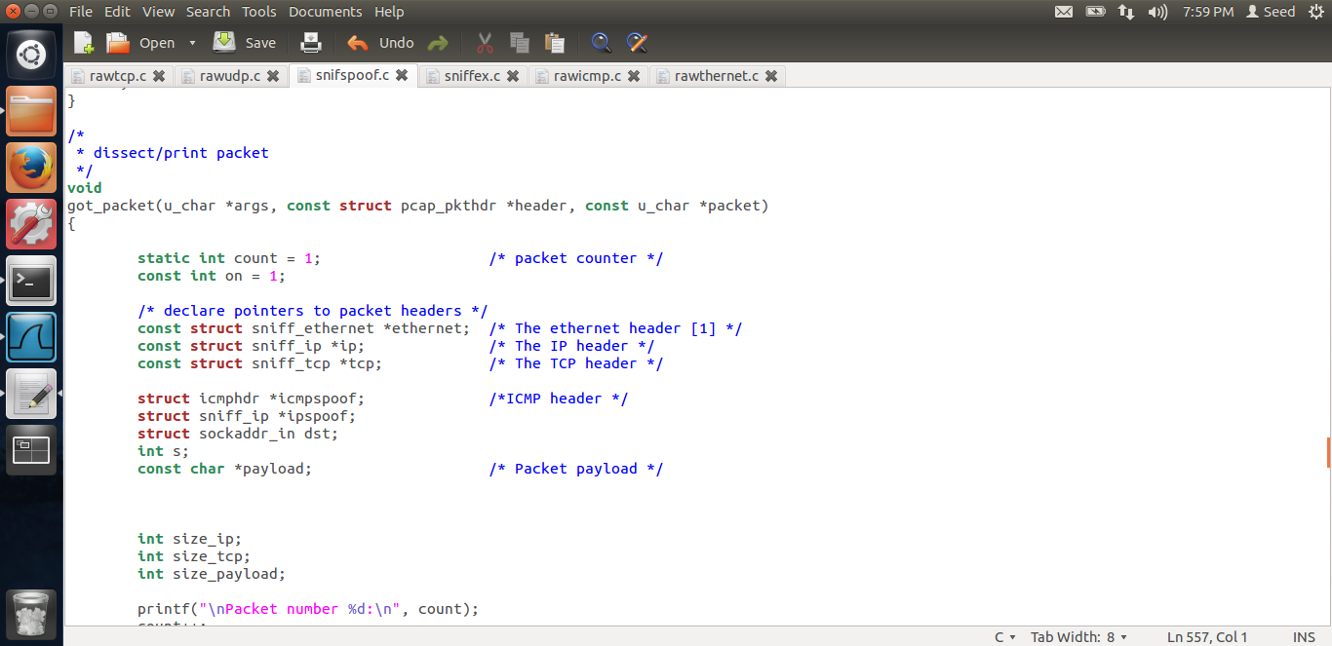

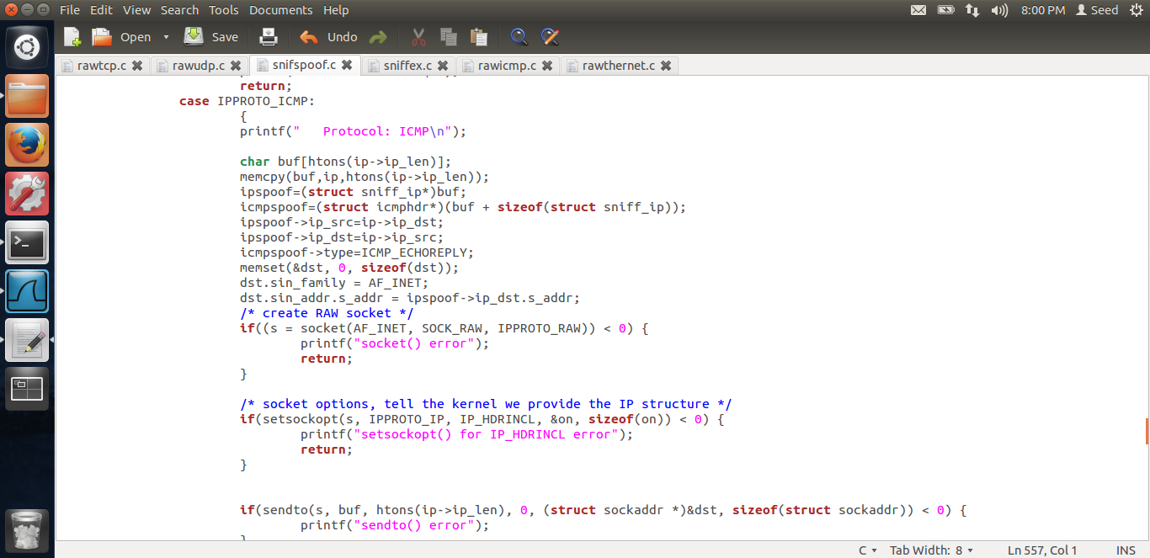

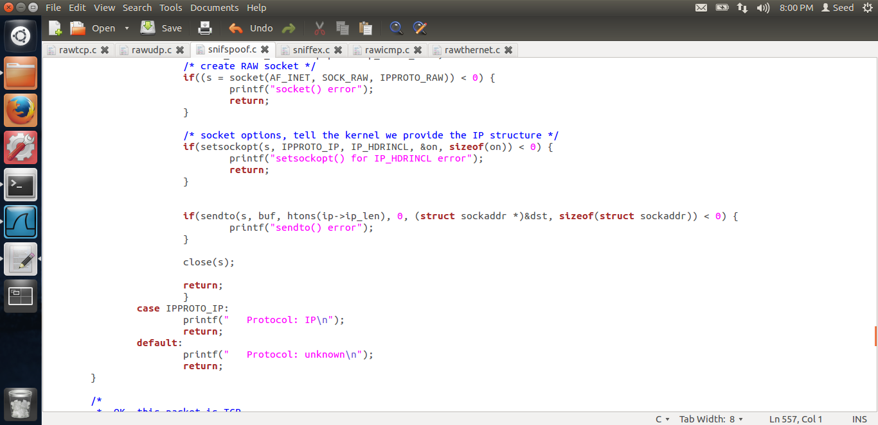

In the above screen shot, we can see that in the callback function, i.e. in got_packet function, I have added struct icmphdr *icmpspoof and struct sniff_ip *ipspoof. The struct sniff_ip is the structure defined in the sniffex program the struct icmphdr is the structure in the c library. I have included these files in the program above.

#include <netinet/ip_icmp.h>

. These pointers I have added because we need to spoof the ICMP packet.

After that I have created a socket_addr reference dst and an int s which will be used for socket.

Then, in the case IPPROTO_ICMP, I have added the code to spoof the packet. This code goes in this case when there is an icmp packet. Here, I am creating a character buffer, the length I am taking from the ip->len field. Then I am doing a memory copy into the buffer of the packet, the packet which we receiver. I am copying from the ip header till the end of the packet. Now, I have copied the packet in the buffer. Now I typecast it to the new ipspoof pointer and the icmpspoof pointer. Then, I change the source address to the destination address and the destination address to the source address. Then I change the icmp type to ICMP_ECHOREPLY. These are the only changes which are needed. Once these are done, I create the socket as usual and then send the spoof packet. Thus, the overall flow is, get the packet, typecast it to Ethernet header, ip header, to get the data, create a buffer, copy the packet,then create an icmp and another ip struct pointer, change the src and dst ips in this new struct value, change echo type and send the packet.

Now, let us see the output.

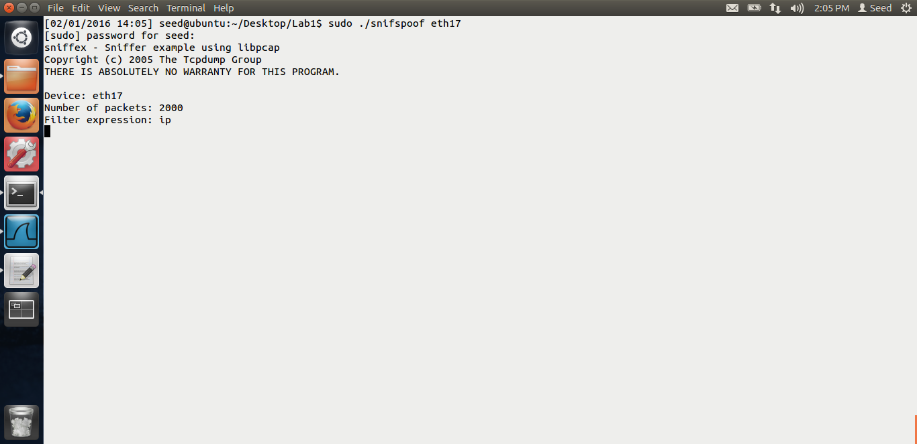

I am starting my snifspooc program, in my original vm.

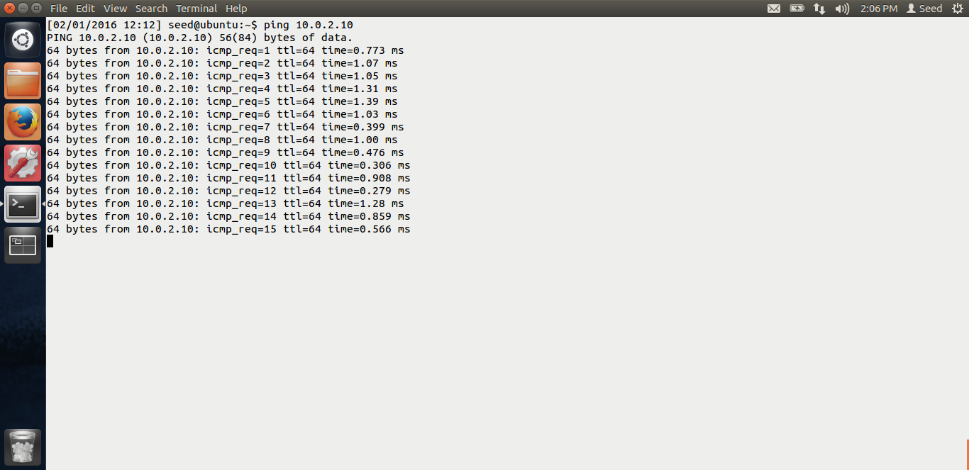

From the clone vm, I am pinging the ip 10.0.2.10 which does not exist. Thus, even though, I am pinging a non-existing ip, I am getting the reply. Thus my snif and spoof program works.

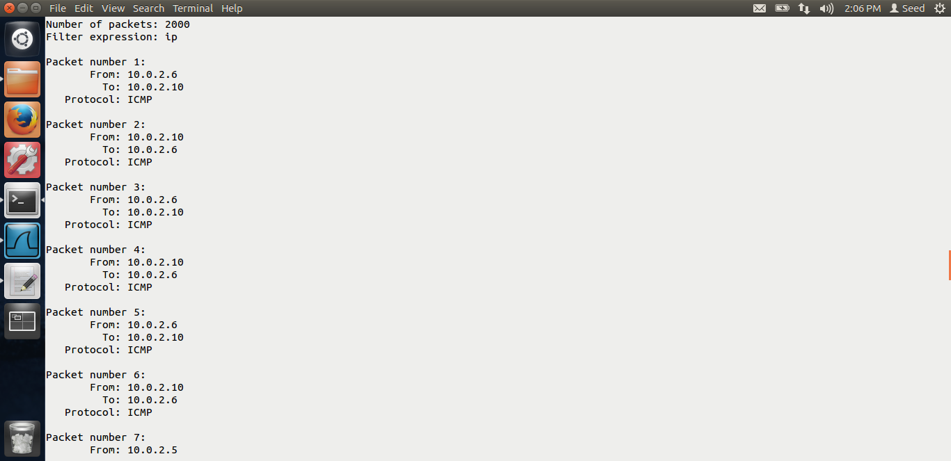

We can see the packets being sent from 10.0.2.6 to 10.2.2.10 and vice verse in the original vm output.

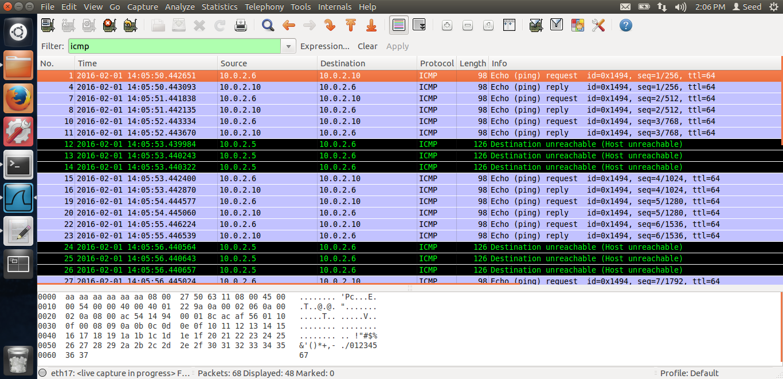

In the wireshark, in the blue color, we can see the request and the reply also. Thus, the sniffing and spoofing program works.

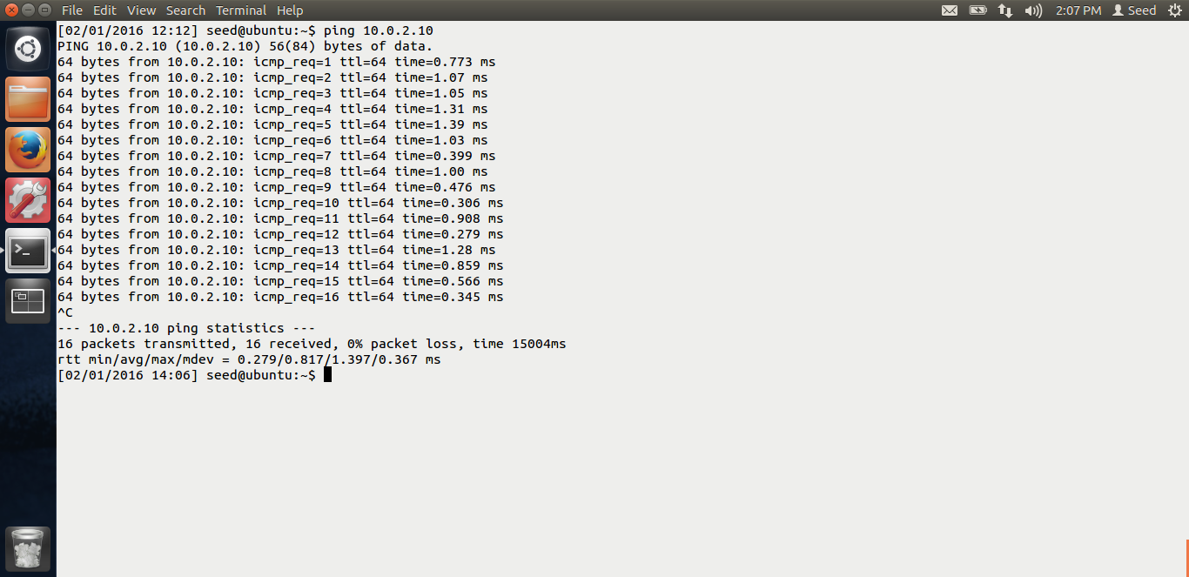

This is the clone vm. We can see that the packet loss is 0%, that means, the ping is successful even though it is to a non existing machine. Thus I have successfully sniffed and spoofed ICMP echo request.

End of task 3.